Ozone Mobile Development Environment Setup

Signing up for lab76

Generating an SSH key

Creating your lab76 account

Changing your lab76 password for the first time

Getting set up with GitLab

Getting added to the repo on GitLab

Adding your SSH key to GitLab

Cloning the Git repo

Setting up Android Studio

Downloading and Installing Android Studio

Running and Configuring Android Studio

Installing and Configuring Android API 15

Install the Intel HAXM drivers

Special note for OS X 10.9 (Mavericks) users

Importing the Android Project

Setting up an Android Virtual Device (AVD)

Making sure everything works

Deploying onto an Android device

Enabling USB debugging

Configuring your development system to recognize Android devices

Mac OS X

Windows

Linux

Deploying to the Android device

Setting up Xcode

Signing up for an Apple ID

Installing Xcode

Running Xcode for the first time

Testing everything out

Deploying onto an iOS device

# Signing up for lab76

Before you setting up the Android Studio IDE or Xcode, you should generate an ssh key, and sign up for lab76. We use lab76 for JIRA and git. **If you already have a lab76 account, you can skip this step.** Also, keep in mind that after you register for an account, it must be approved. **This can take up to 24 hours.**

## Generating an SSH key

Generating an ssh key is easy. First, open a console and simply type:  
*ssh-keygen*

And press enter. It will prompt you for a location for the resulting files: press enter to keep it as the default. It will then prompt you for a passphrase and a confirmation. I usually keep this blank for ease, but for added security you can add one. Afterwards, you’ll get a prompt that everything was created successfully:

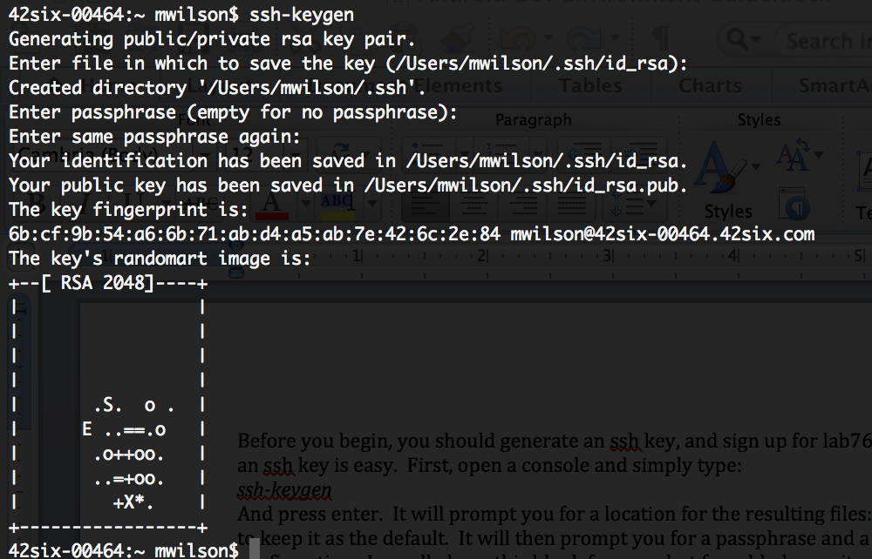

After this, type:

*cat ~/.ssh/id_rsa.pub*

This will output your public key to the console. Highlight and copy this. We’ll need it for the next step.

## Creating your lab76 account

Navigate to <https://www.lab76.org/>. You’ll be presented with the following screen:

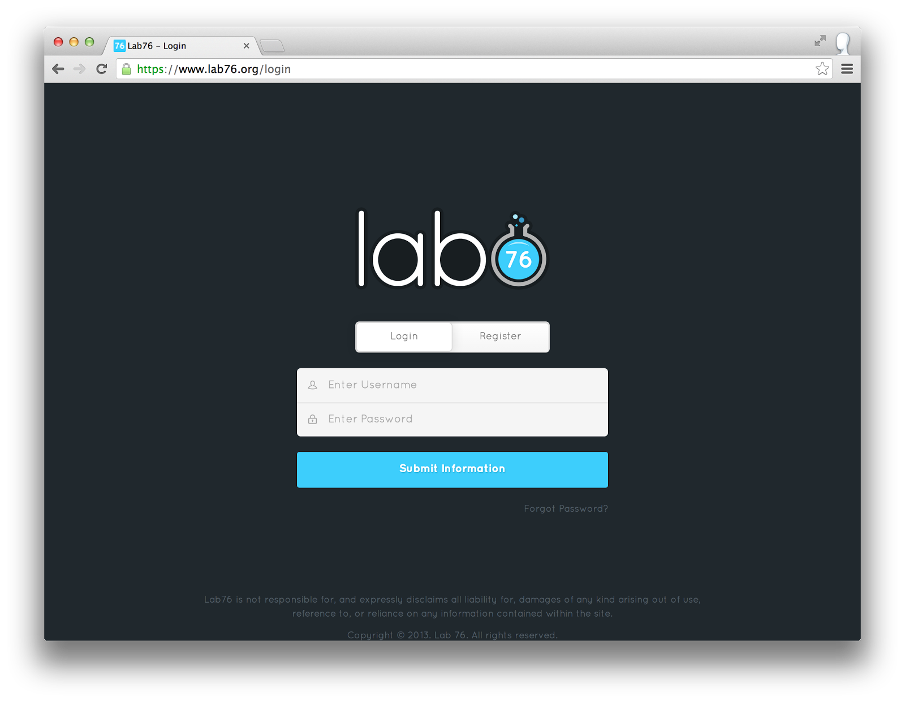

Click on “Register.” The prompt should change, and you’ll need to select your team (select 42six) and your role (select Developer). The page should look like this:

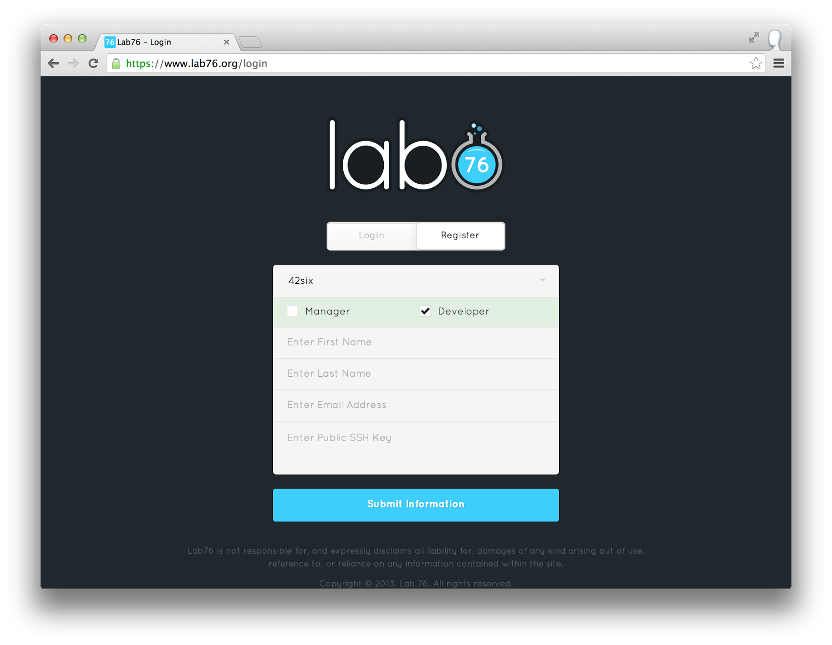

Fill out the rest of this with your information and 42six e-mail address. For the Public SSH key, paste the string you copied from the previous step into here. Then click submit. You should get a confirmation e-mail very shortly. **However, it can take up to 24 hours to confirm your account.** Make sure you do this step as early as you can!

## Changing your lab76 password for the first time

You’ll get a confirmation e-mail with login instructions. Follow them to change your password. One note, however: you may receive an error when attempting to do this. If you receive an error that says:

LDAP password information update failed: Constraint violation

Password is too young to change

passwd: Authentication token manipulation error

Connection to proxy.lab76.org closed.

Contact support@lab76.irg and let them know. They should be able to fix it for you shortly.

# Getting set up with GitLab

## Getting added to the repo on GitLab

Contact Jason Lettman to have him add you to the GitLab repo once your lab76 account has been set up.

## Adding your SSH key to GitLab

In addition to using your SSH key to sign up, you’ll also need to add it to GitLab in order to check things out of the Git repository. After your lab76 account has been set up and you’ve successfully set up your password, navigate to <https://git.lab76.org/>. Up at the top of the screen, click on the third icon from the right, which is “Profile Settings.”

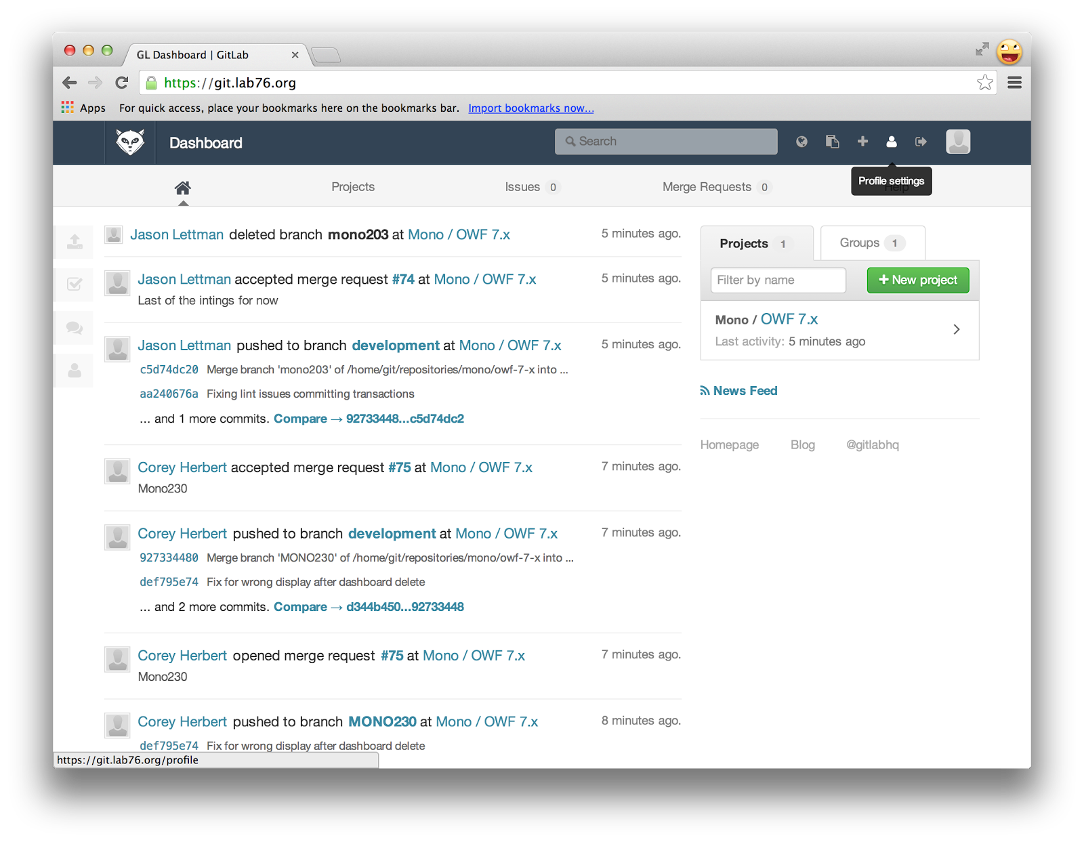

This will bring you to your profile page. On the menu at the top of the page, click on “SSH Keys.”

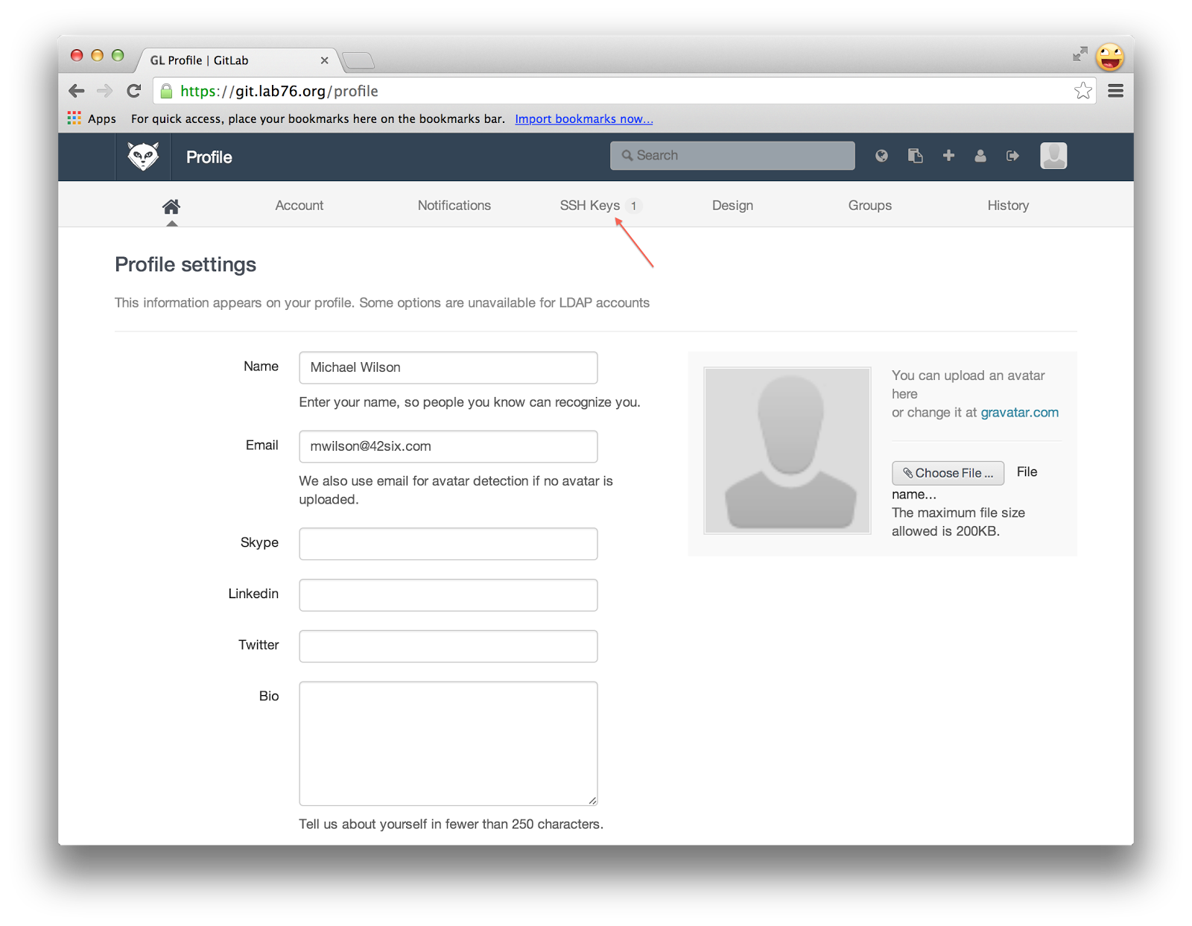

The next screen will be a list of the SSH keys associated with your account. This will be empty for you. Click on the green button that says “Add SSH Key.”

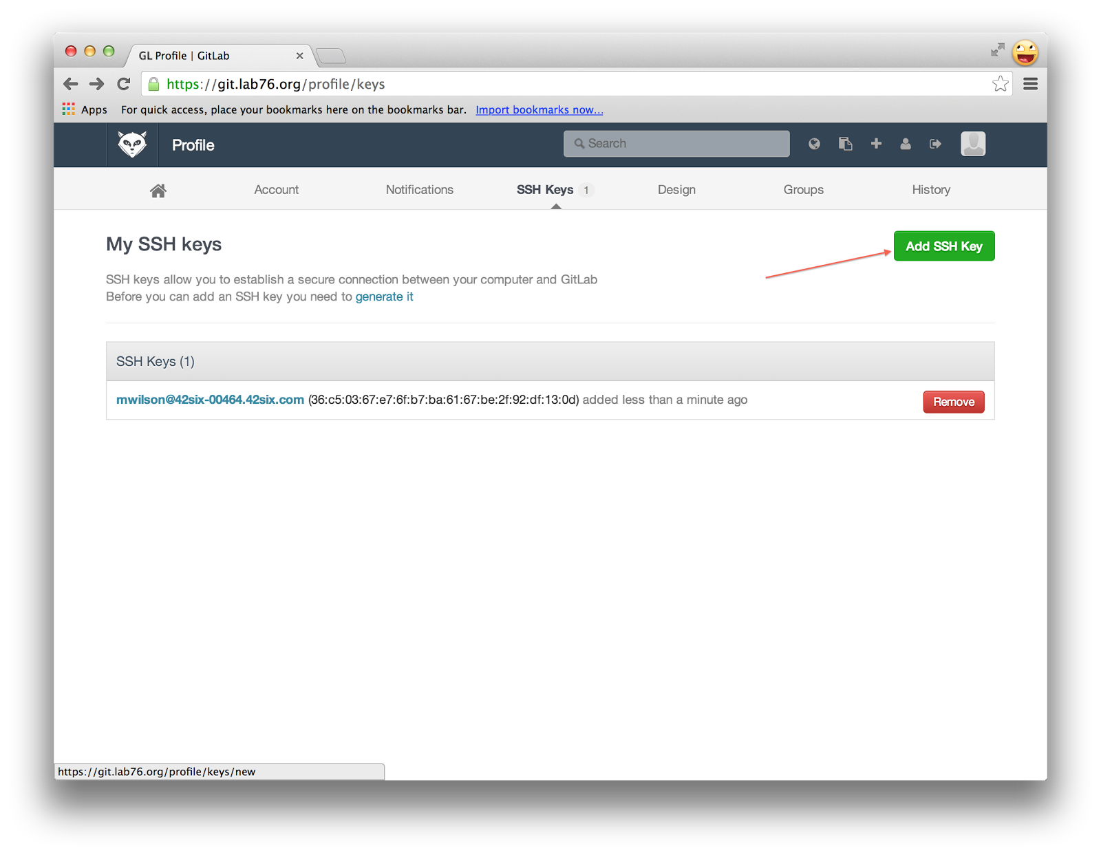

Take the SSH key you copied from earlier and paste it into the large text box labeled “Key.” It will autofill the “Title” for you.

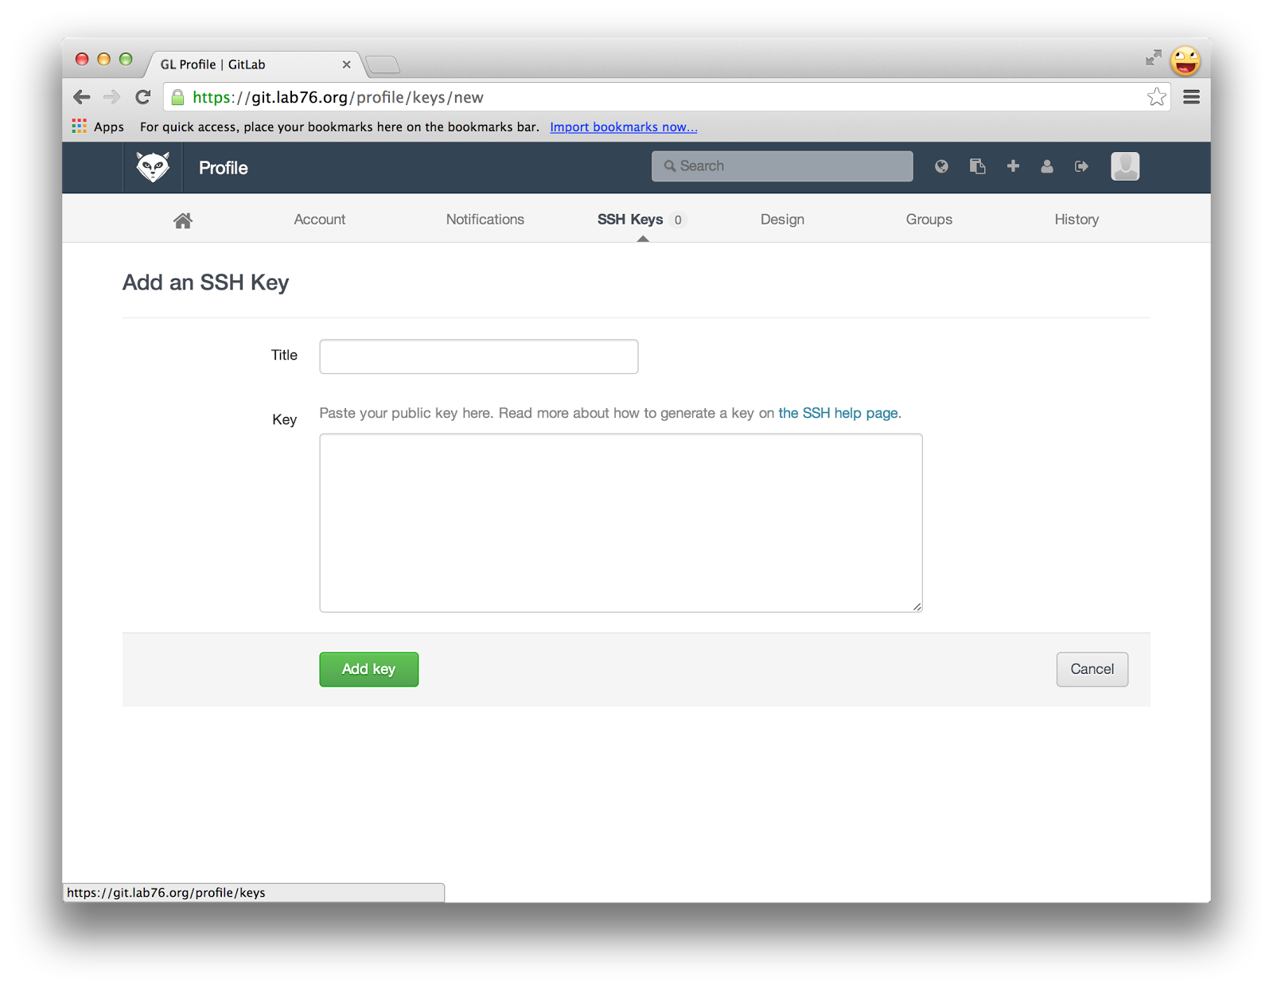

Click “Add key” at the bottom and you’re done!

# Cloning the Git repo

Both Android Studio and iOS will require access to the git repo. Additionally, both have a native ability to clone into git repositories. Both IDEs tend to want to “own” the git repository and set the repository up in its own space. Rather than do that, we can clone the repository ourselves. Not only is it significantly faster to do, it will lower the complexity of setting up Android Studio and Xcode.

In a terminal, make a directory that you’d like to house your repository. You can make the directory using mkdir. So, if you’d like to store all your repositories a directory called “repos” in your home directory, you’d say:

*mkdir ~/repos*

Afterwards, cd to that directory:

*cd ~/repos*

Finally, issue the clone command:

*git clone git@git.lab76.org:mono/owf-7-x.git*

Let that command finish, and then cd to owf-7-x directory. Checkout the development branch.

*git checkout development*

# Setting up Android Studio

## Downloading and Installing Android Studio

In order to get your Android development environment up and running, first you’ll need to get Android Studio. To do this, navigate to <http://developer.android.com/sdk/installing/studio.html> and click on the blue “Download Android Studio” button.

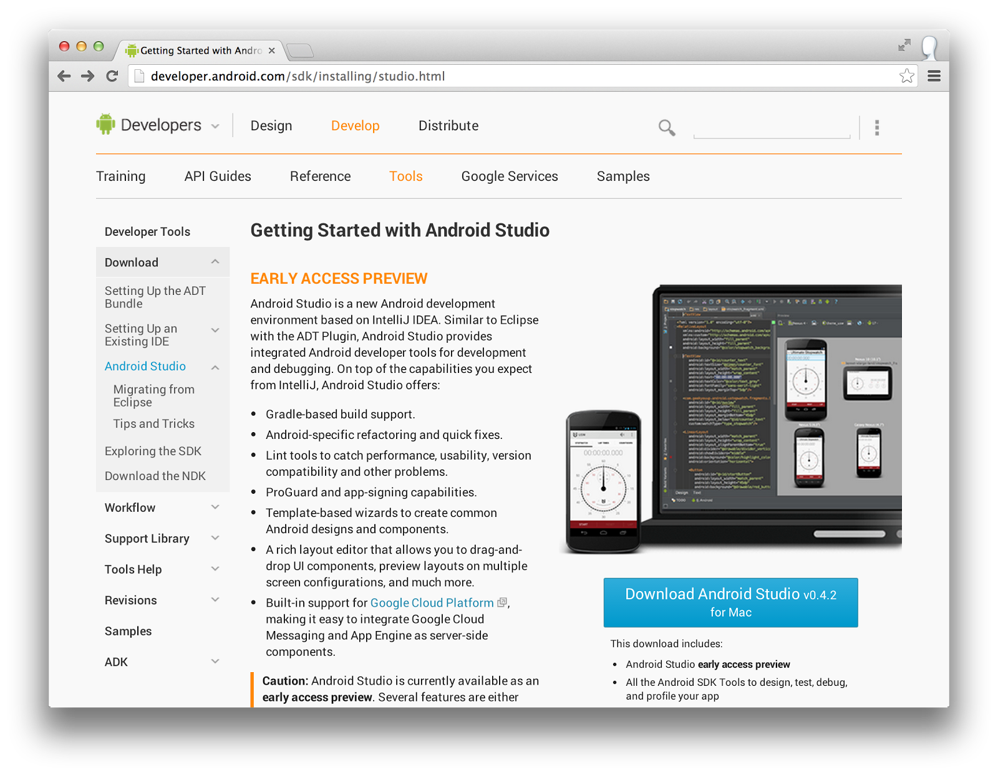

This will take you to a terms and conditions screen. Read through the document, check the box next to “I have read and agree with the above terms and conditions,” and click “Download Android Studio” below the check box.

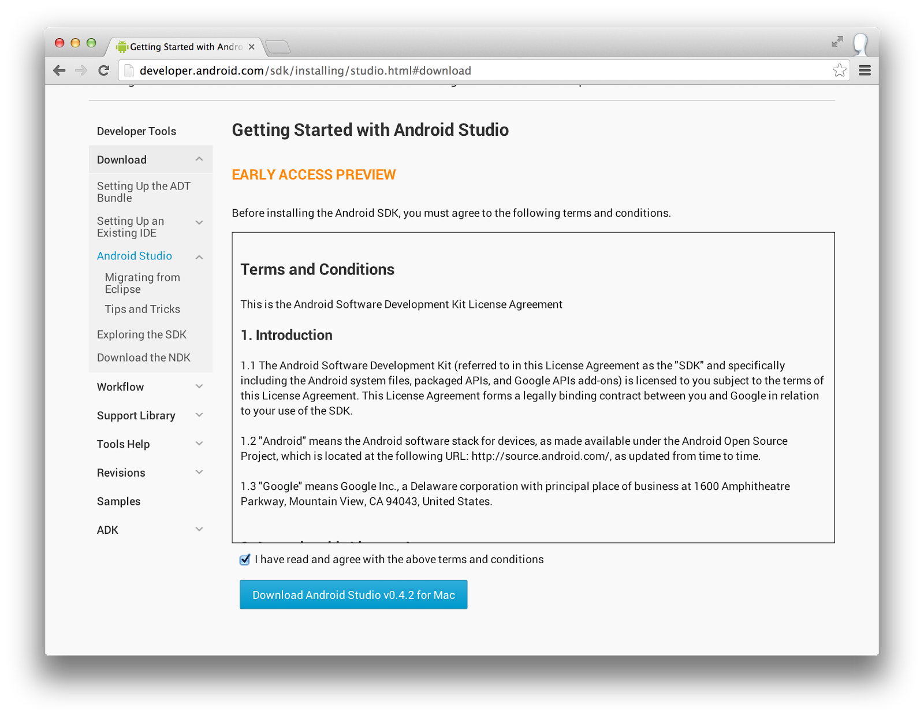

This will trigger the download. Once the download is complete, open the dmg (this should happen automatically). A folder should pop up with the contents of the dmg. Drag Android Studio over the the “Applications” link. This will install Android Studio.

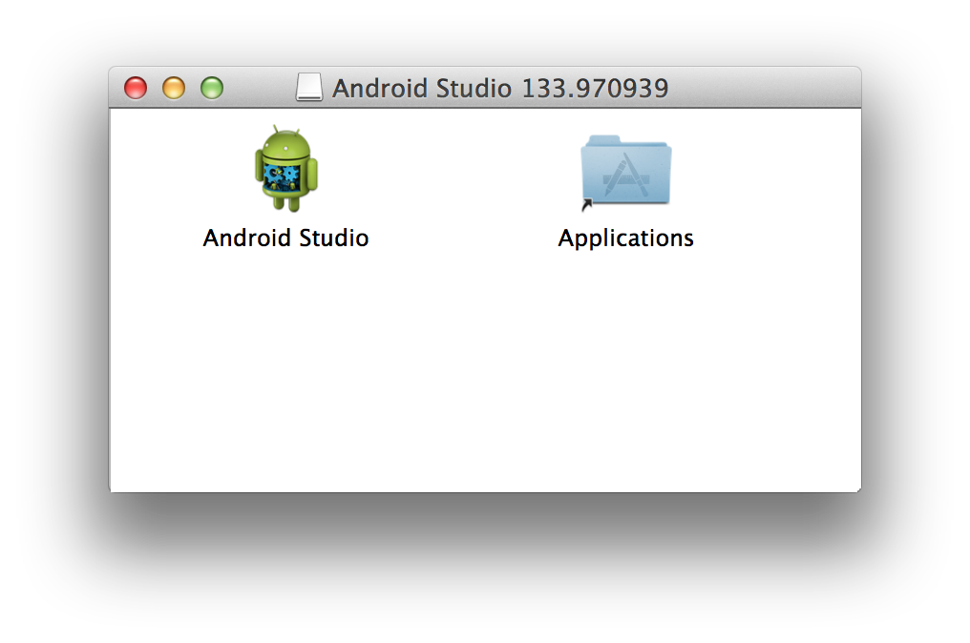

This should take only a minute or two.

## Running and Configuring Android Studio

Navigate to your Applications in Finder, and open Android Studio. If you don’t already have Java installed, Android Studio will prompt you and ask if you want it to be installed. Click yes here and wait for the installation to complete. You may see an upgrade pop up. Versions 0.4.2. to 0.4.6 work with Mono’s configuration. Do not install 0.5.x at this time. After Java installs, you may have to re-launch Android Studio. You’ll be presented with the following splash screen:

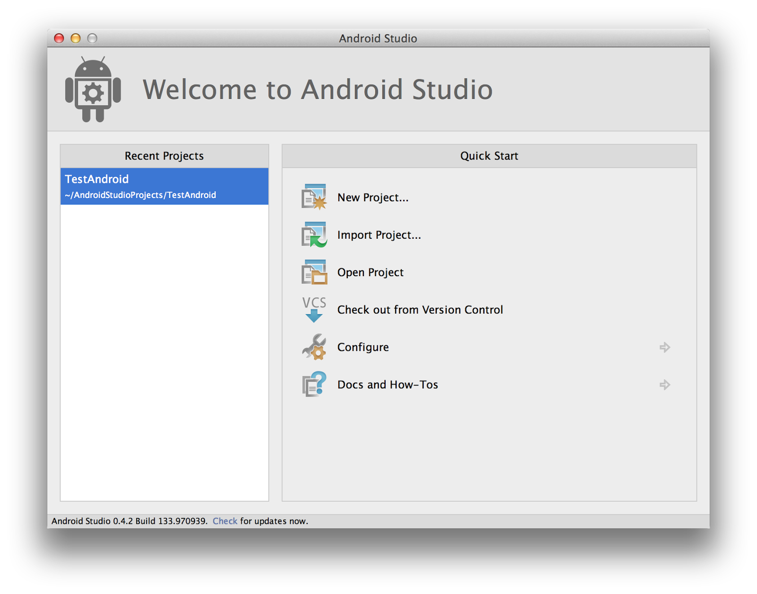

### Installing and Configuring Android API 15

Before we do anything, we need to configure the proper Android platform we’ll be working on. Click on “Configure -> SDK Manager.”

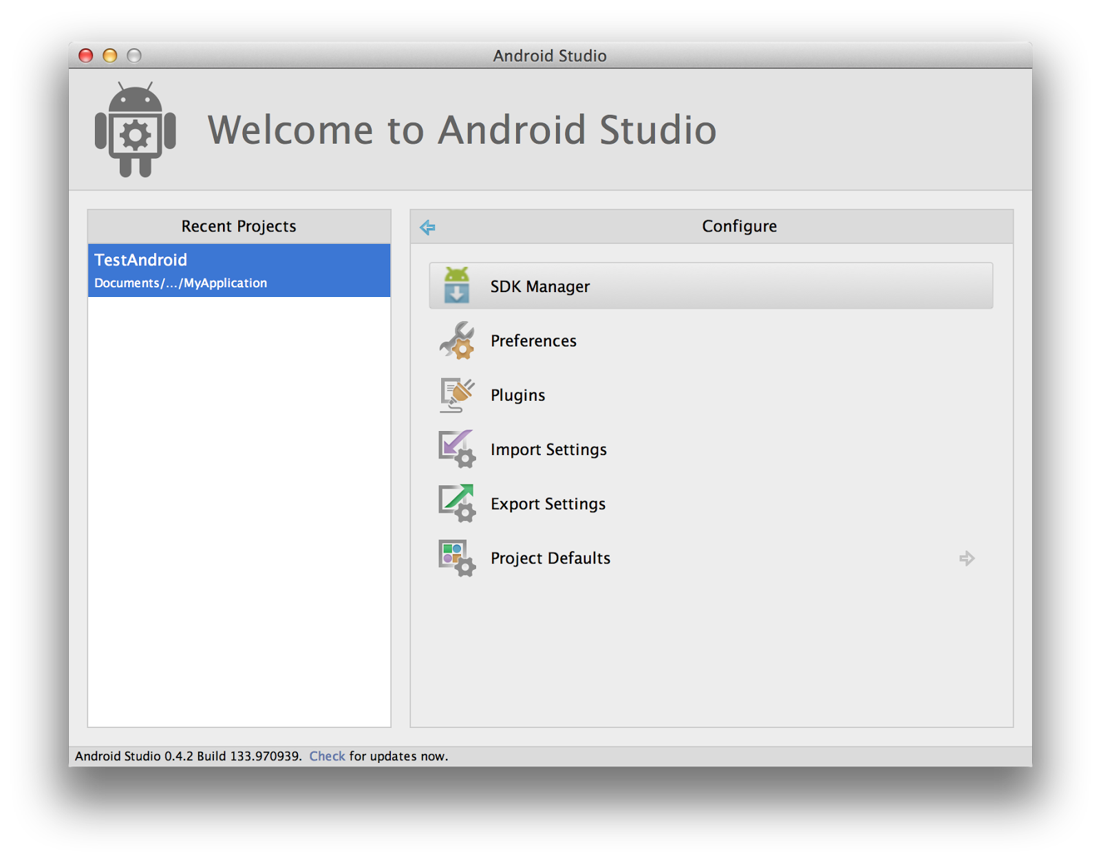

Go to the menu bar at the top of the screen and select “Tools -> Android -> SDK Manager.” We need to adjust our development environment to use API 15 in addition to 19. In the window that opens, find the row labeled “Android 4.0.3 (API 15)” and click the checkbox next to it, and then click on “Install packages…” in the lower right. The number of packages may vary depending on your existing installation. You’ll be presented with a license acceptance screen. It’ll look like this to begin with:

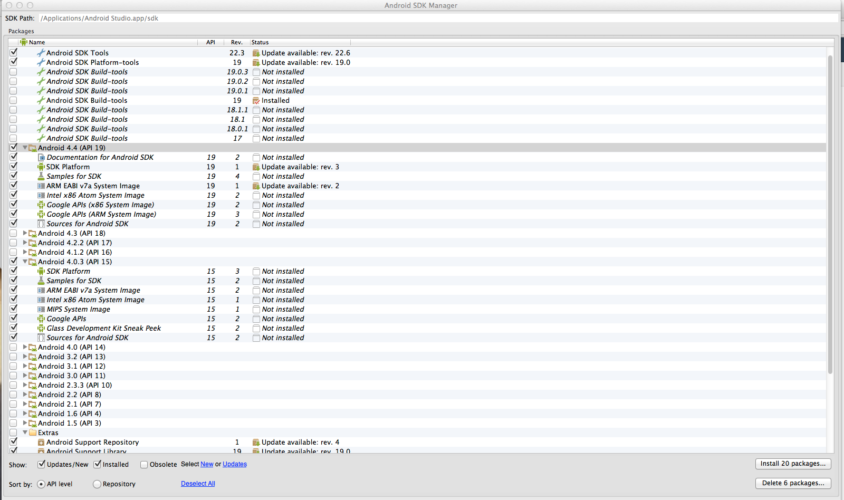

We need to accept all these licenses. Click on the top level elements (Android SDK License, Google Gdk License, Intel Android Sysimage License, and MIPS Android Sysimage License) and click “Accept license” on the lower right part of the window for each of them. When you’re done, there should be checkmarks by each package that will be installed. After this, you can click “Install.”

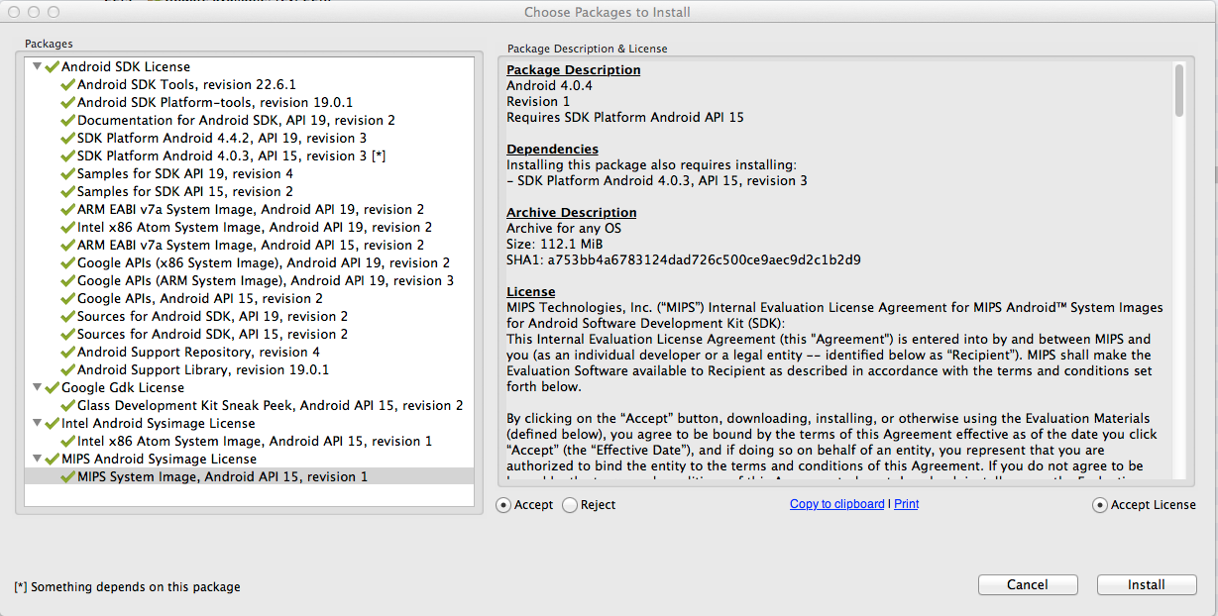

This will kick you back to the original SDK Manager window with a progress bar at the bottom. It will take a few minutes to install everything. Let it finish before progressing. Once it’s done, all of the packages listed within Android 4.0.3 (API 15) in the SDK Manager window should be marked “Installed.”

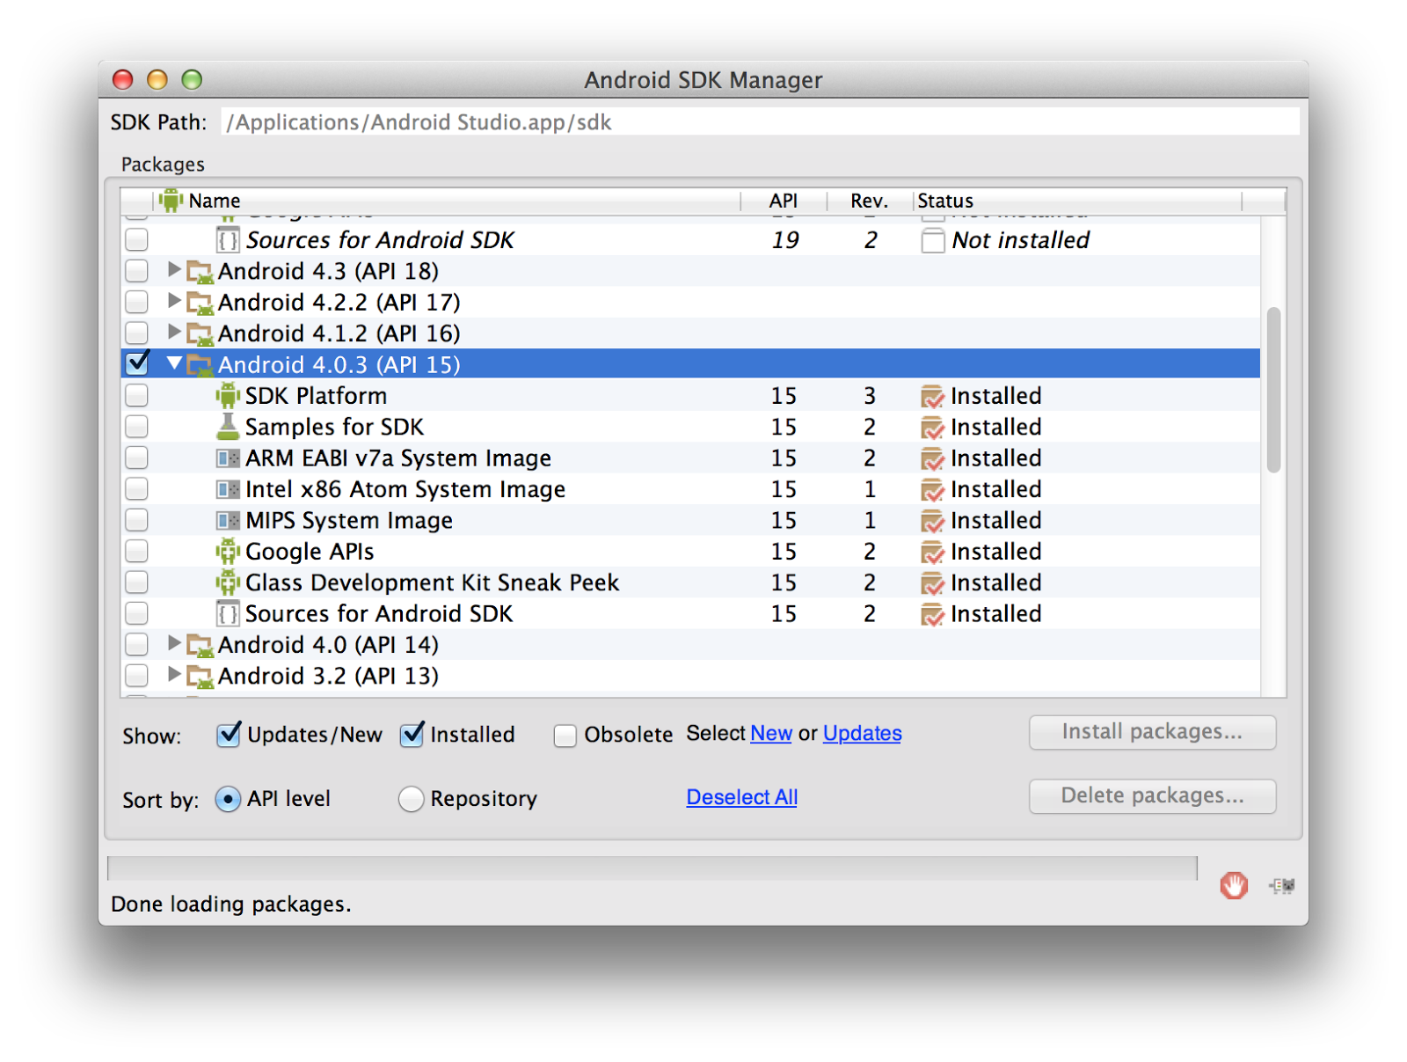

Before we leave the SDK Manager, ensure the Android SDK Build-tools version 19 is installed. Depending on your Android Studio version and updates, it may already be installed for you. Locate that above in the “Tools” folder. Click the checkbox near it and click “Install 1 package…” if it is not already marked installed.

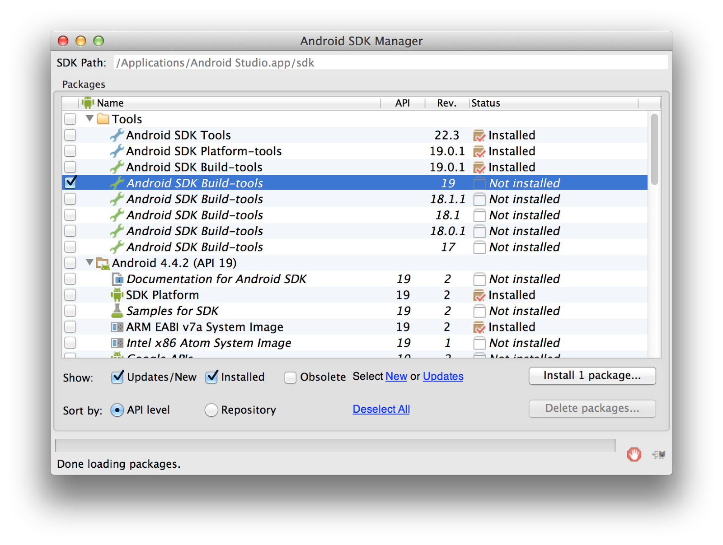

If not already installed, you’ll have to accept the license for that as well, and then click “Install.”

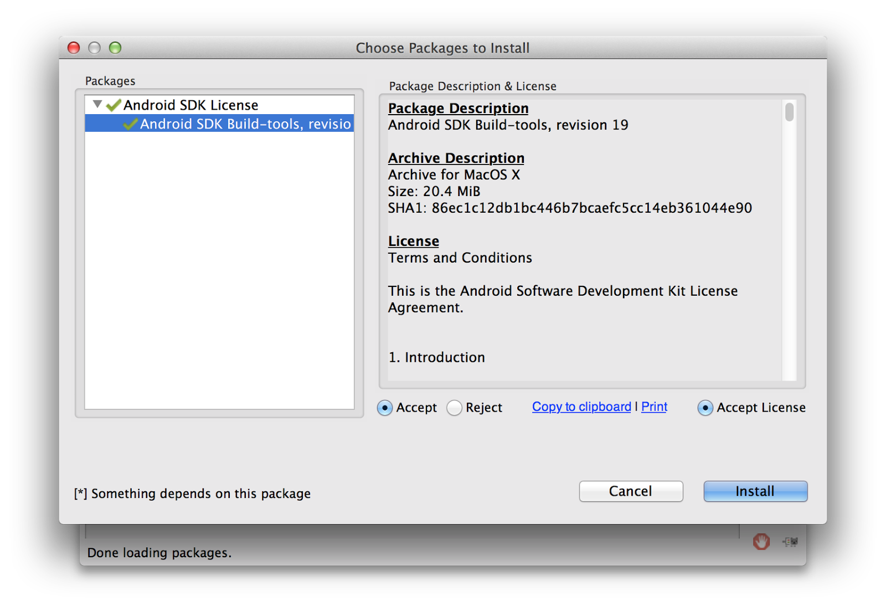

Finally, we want to install the Intel x86 Emulator Accelerator (HAXM). In the SDK Manager, if you browse to the bottom of the list to the Extras folder, you’ll see it. Click the checkbox near that and click “Install 1 package…” Again, accept the license and click “Install.”

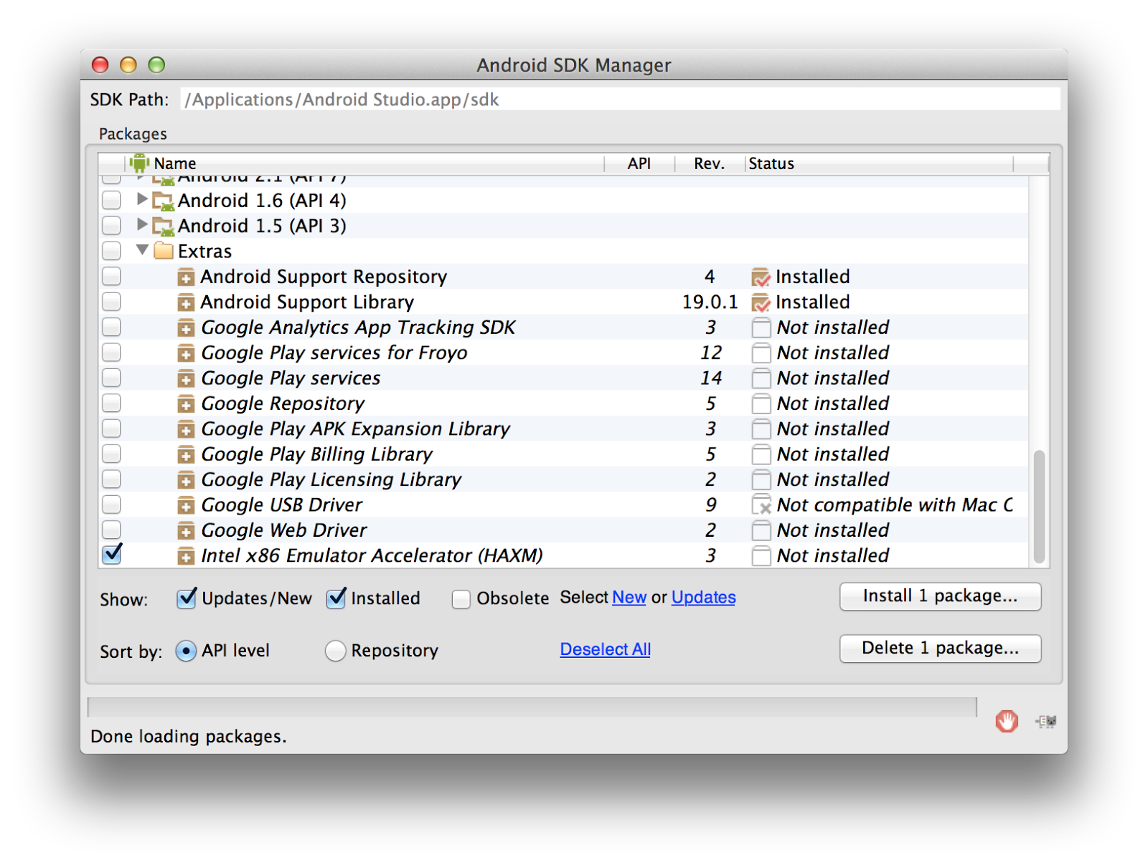

**Note:** You can select all of the packages at once and install them all at once if you so desire.

After this, you can close out the SDK Manager. Let’s set up the SDK we just installed within Android Studio. On the original splash screen you should still be in the configure menu. Go to “Project Defaults -> Project Structure.” In this window, select “SDKs” on the left hand side under “Platform Settings.”

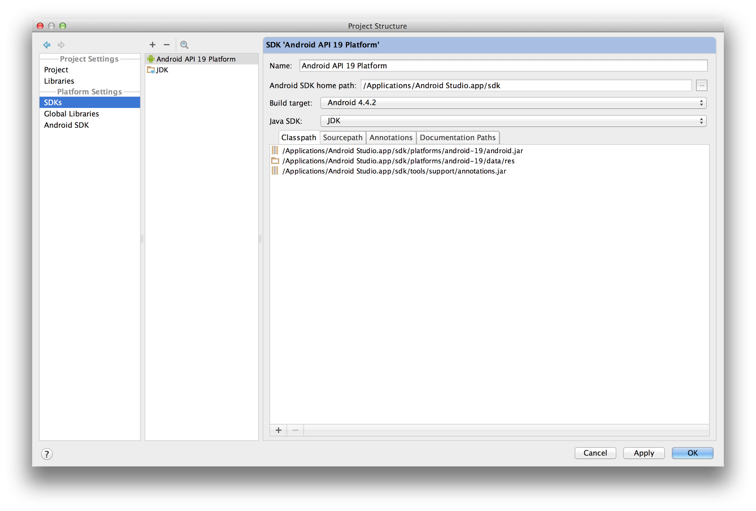

You’ll most likely already have Android API 19 Platform as well as a JDK entry. Let’s add API 15 to this list. Click the plus button above the list of currently recognized SDKs, and select “Android SDK.”

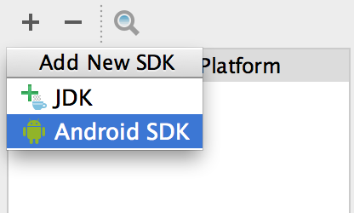

You’ll be presented with a file selection window. Navigate to Applications. Then double click on Android Studio, which will take you within the file structure of the application. Click on the “sdk” directory here, and then click “Choose.”

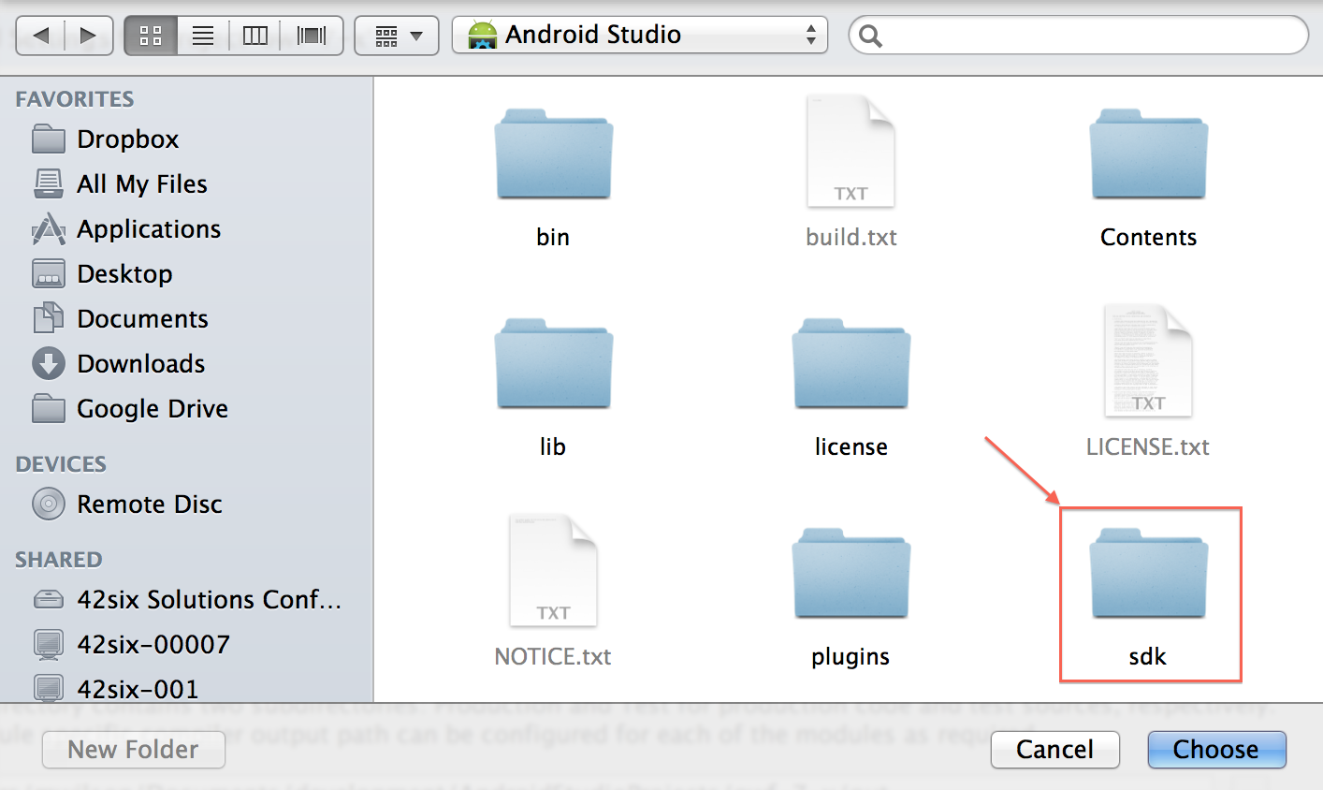

After this, you’ll be presented with a list of available SDKs. Select “Android 4.0.3,” and click “OK.” If Android 4.0.3 does not appear in the list after installing with SDK Manager, restart Android Studio and try again.

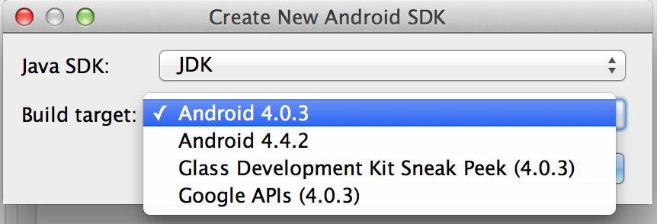

Now, in the list of available SDKs, Android API 15 Platform should be available.

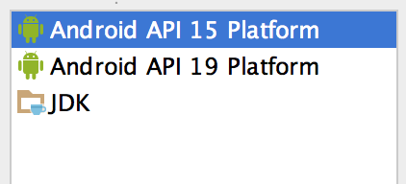

You’re done configuring the Android SDK now. You can click “OK” on the lower right part of this window. For the next step, go back to the main splash screen by clicking the Back button until you get back to the “Quick Start” menu.

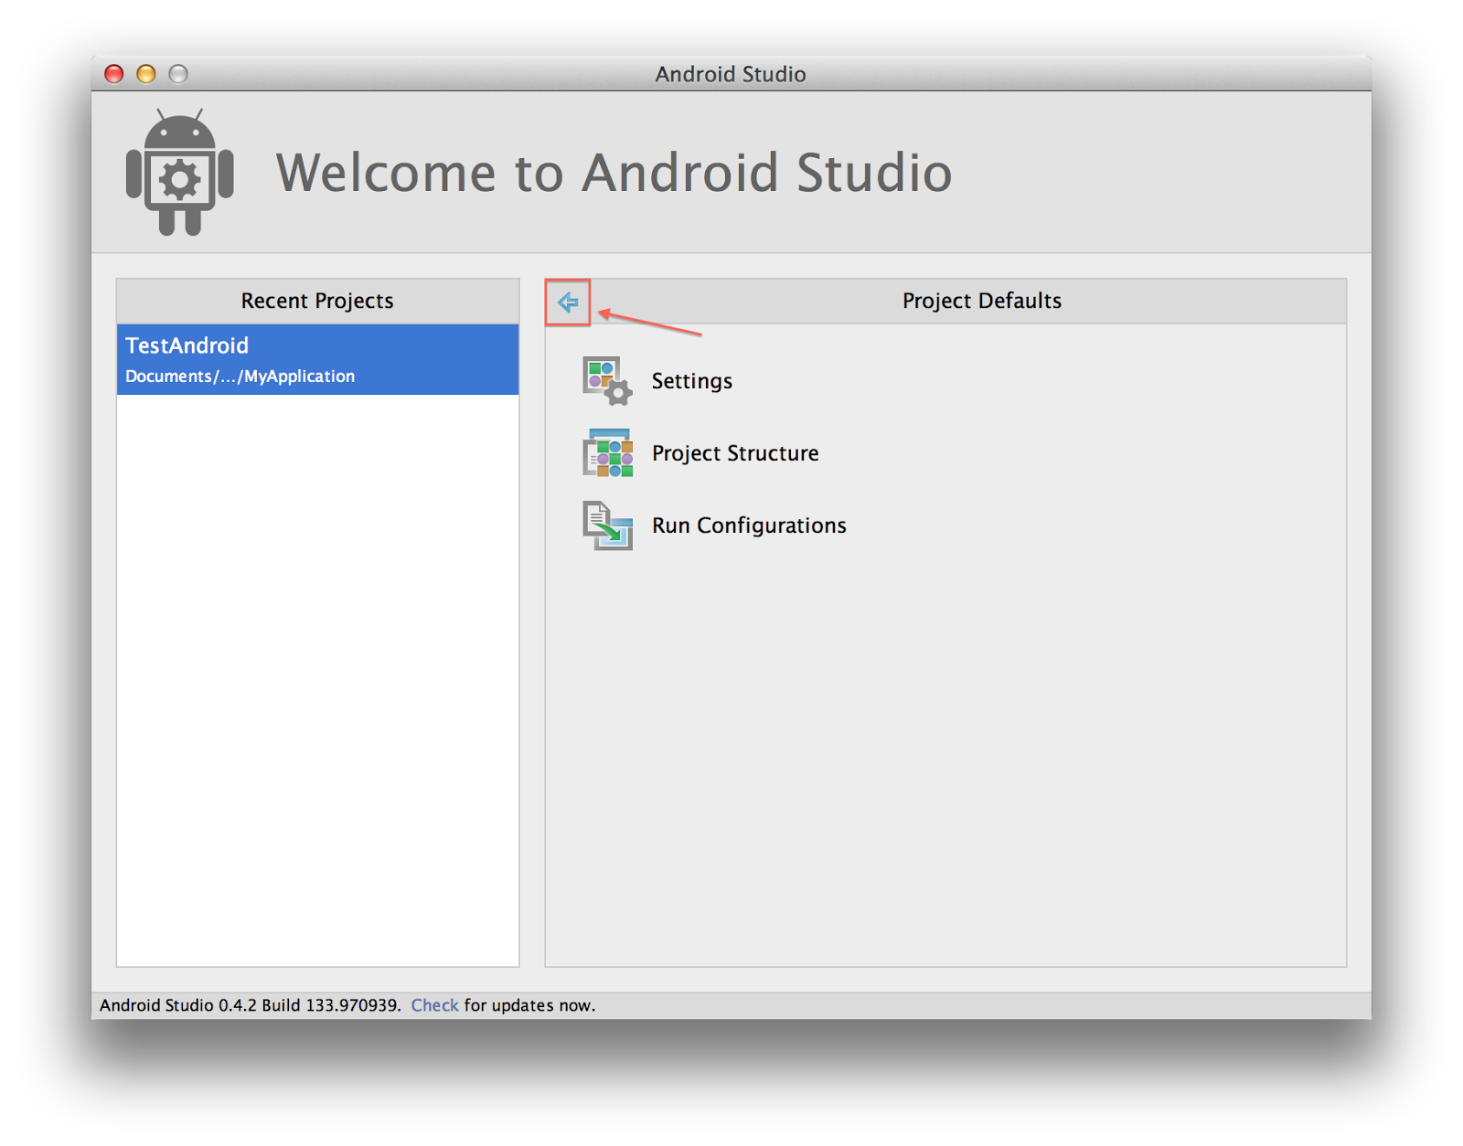

## Install the Intel HAXM drivers

**If you have OS X 10.9, please skip to the subsection of this section**

In order to speed up Android emulation, which we’ll set up later, we need to install the Intel HAXM drivers. By selecting it in the SDK above, it was downloaded locally. However, now we need to actually execute the installer. Open up a Finder window, and navigate to Applications. Right click (or Ctrl+Click) on Android Studio and select “Show Package Contents.”

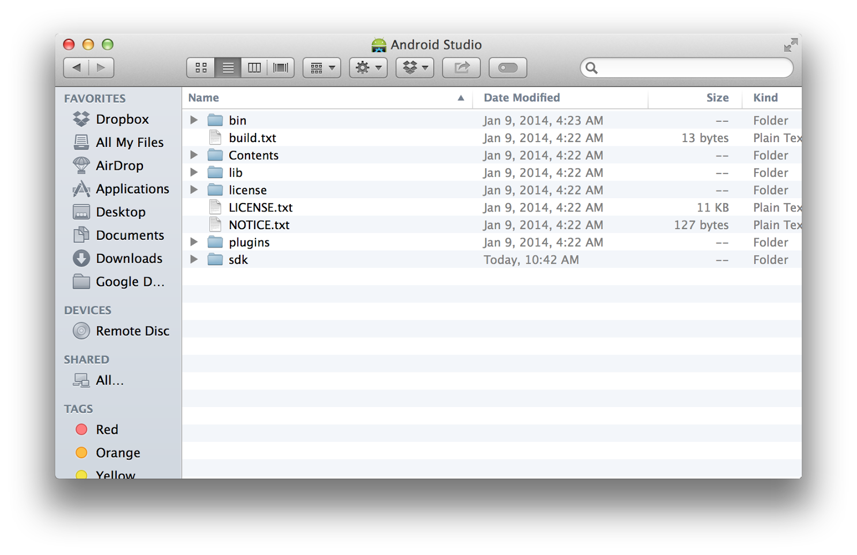

Navigate to sdk -> extras -> intel -> Hardware_Accelerated_Execution_Manager, and double click on IntelHAXM.dmg. A window should pop up with a single file, IntelHAXM_1.0.6.mpkg. Double click it to run it.

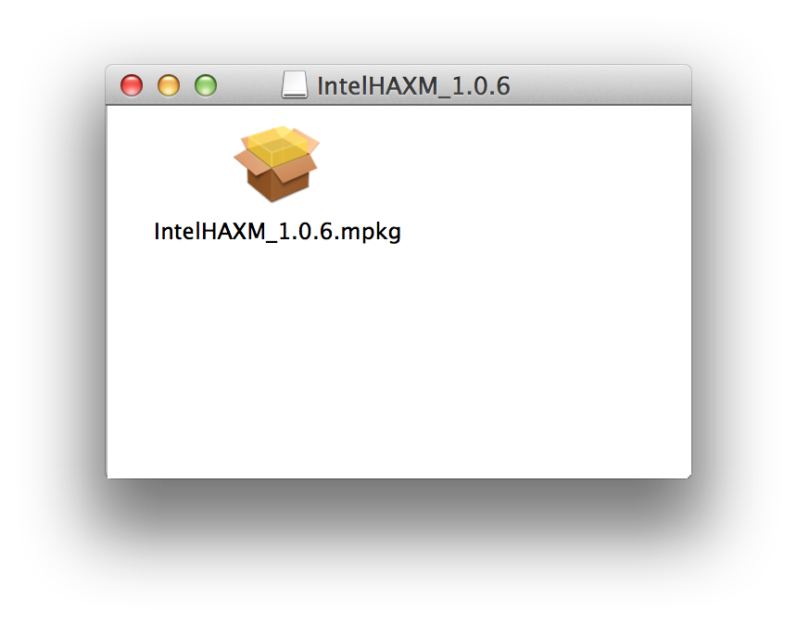

This will guide you through a set up process. Click “Continue” through a prompt, and you’ll be prompted for a memory limit value. Make sure the value doesn’t consume too much physical memory. 1024 or 2048 are good choices.

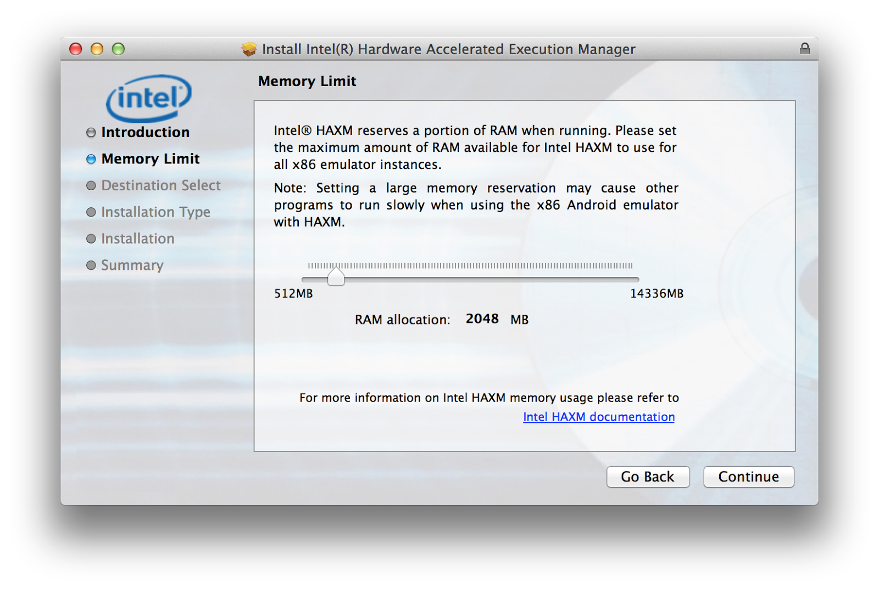

Click Continue/Install for the rest of the prompts, and input your credentials when asked. HAXM should now be installed. If you have OS X 10.9, please look at the subsection for further instructions.

### Special note for OS X 10.9 (Mavericks) users

HAXM has a problem with 10.9. Therefore, we need to get the hotfix from Intel. Download the zip from the URL: <http://software.intel.com/sites/default/files/haxm-macosx_r03_hotfix.zip>. Open a Finder window and navigate to your Downloads folder. Double click haxm-macosx_r03_hotfix.zip to extract its contents. You should get a directory called “haxm-macosx_r03_hotfix.”

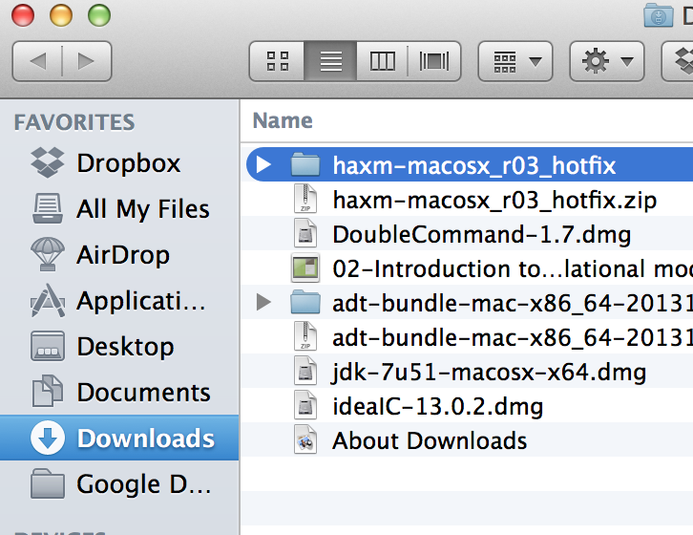

In this directory is a dmg file. Open it, and run the IntelHAXM_1.0.7.mpkg set up file located inside.

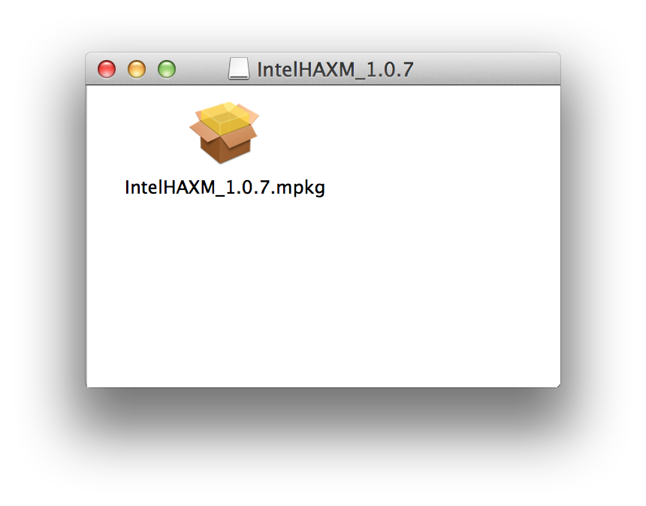

Follow the prompts, and choose either 1024 or 2048 as your memory limit depending on how much physical memory your dev machine has.



If prompted for your credentials, enter them. Afterwards, HAXM should be installed and your Android emulation should run much faster.

## Importing the Android Project

Now that the Android SDK is properly set up, we should import the Android project. From the splash screen, click “Import Project…”

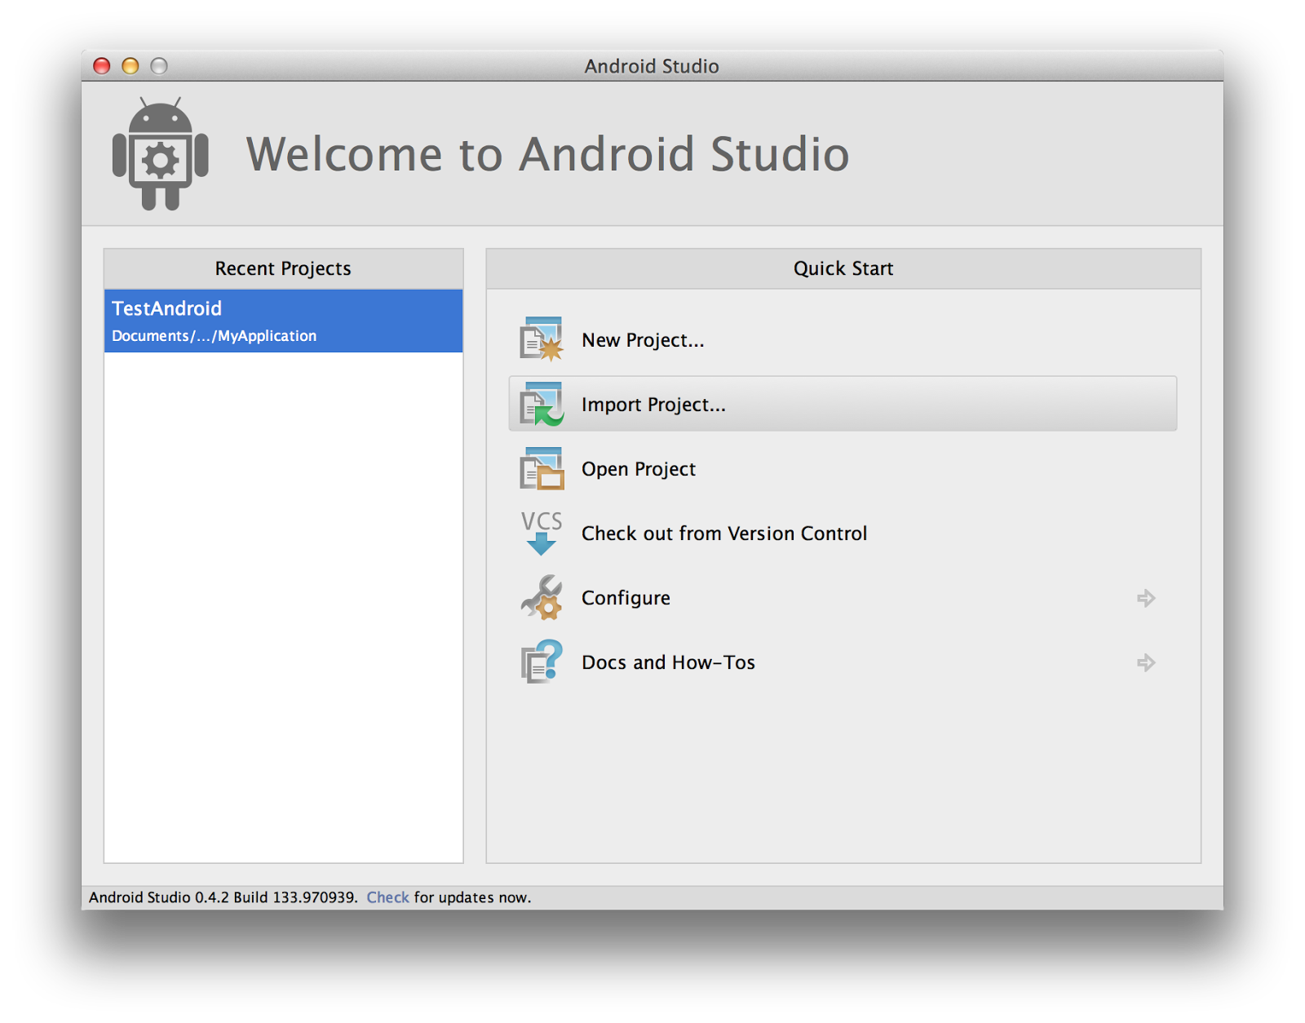

Here, you’ll be presented with a file selection dialog. Browse to the git repo that you cloned. For me, it’s in a subdirectory called “repos” under my home directory. Expand this directory, and then the directory underneath it named “owf-7-x.”

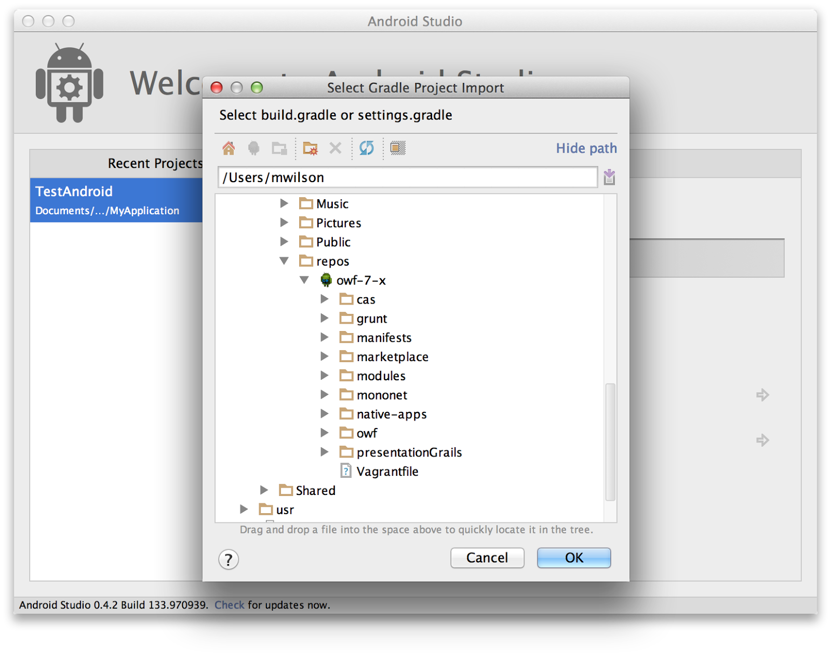

We’re going to import the native-apps/android project. Expand native-apps, select android, and click “OK.” A few dialogs will be presented, and then you’ll be presented with the main IDE. You should see android listed in the project list to the left.

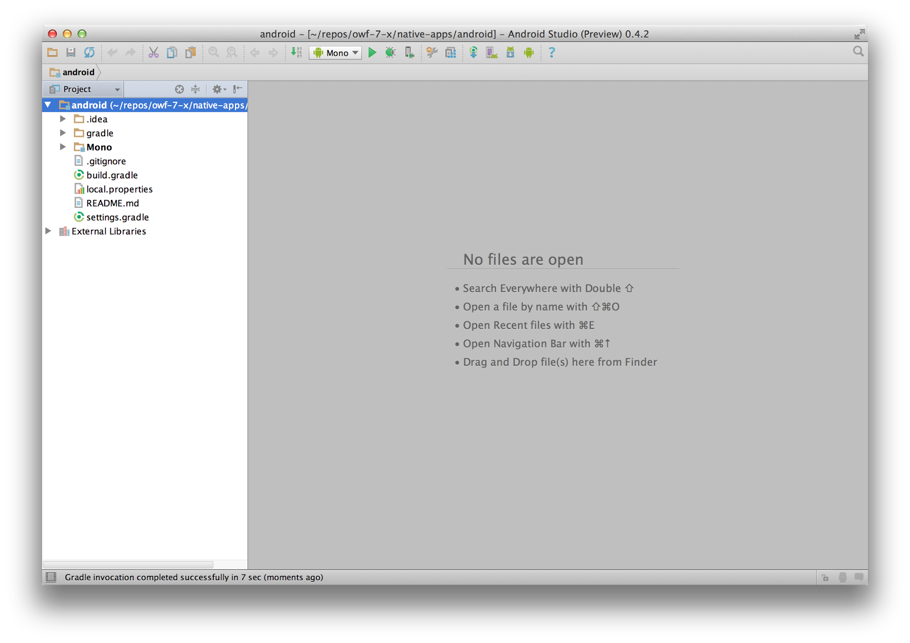

You should now be ready to code. In order to test your code, we’ll need to do one last thing.

## Setting up an Android Virtual Device (AVD)

In order to test out any Android code, we’ll have to set up an Android emulator to mimic an actual Android device to deploy to. To set this up, from the main IDE screen, go to the menu bar and select Tools -> Android -> AVD Manager. You’ll be presented with the following screen:

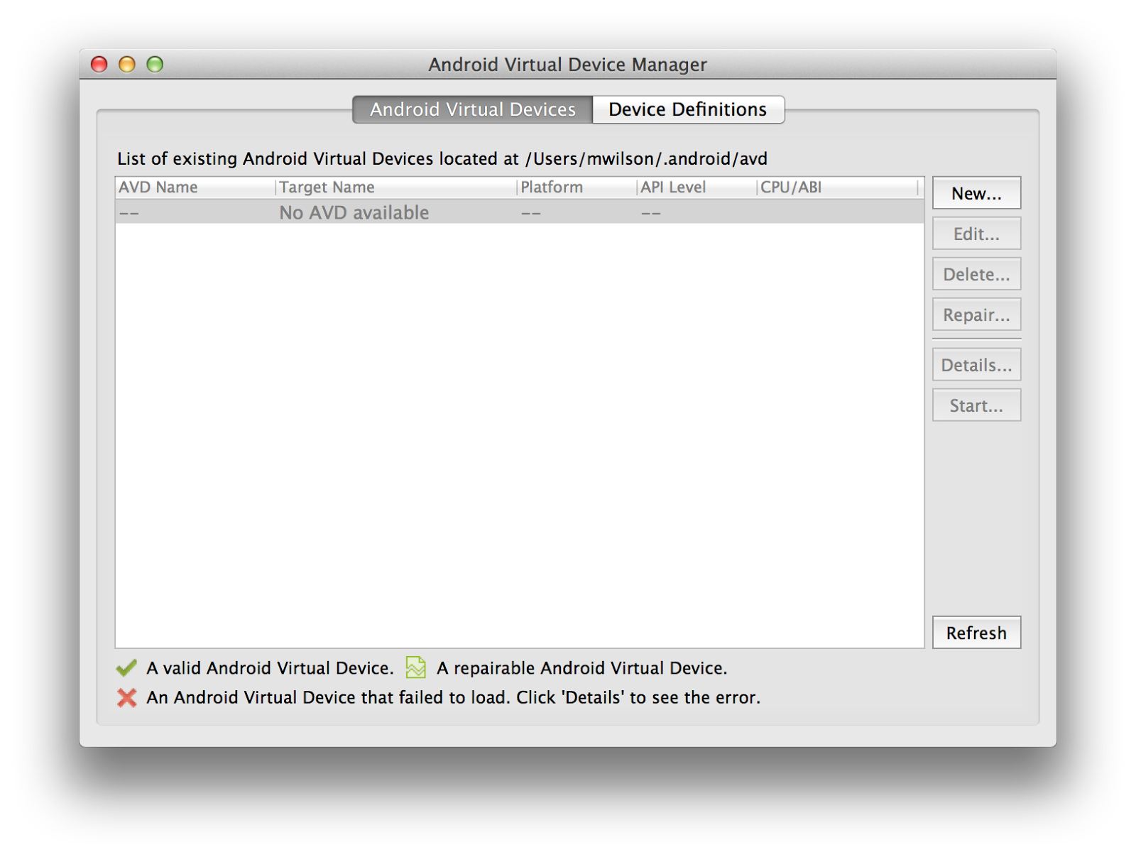

We want to make a new virtual device. Click “New” on the right hand side. You’ll be presented with a virtual device set up screen:

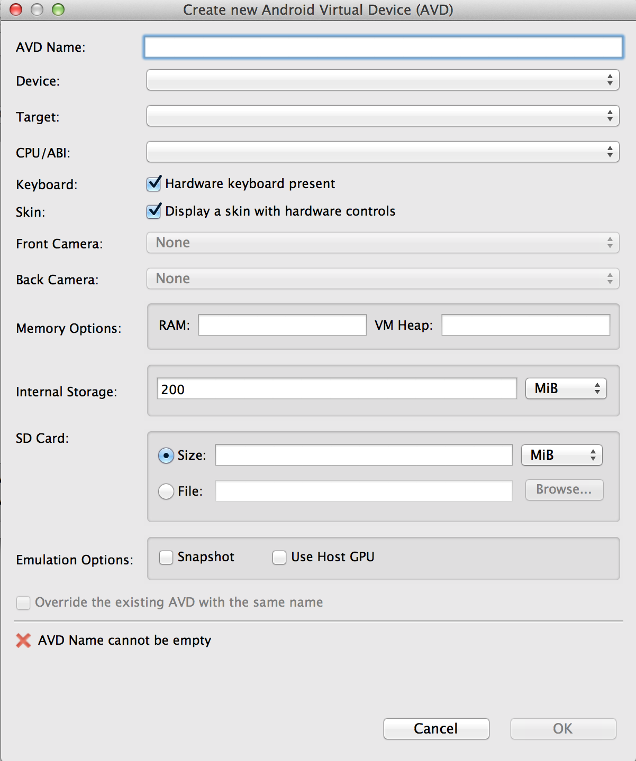

Fill out the AVD Name as anything you want. I suggest “MonoAndroid.” For device, select “Nexus 4.” For Target, select “Android 4.0.3 – API Level 15.” For CPU/ABI, select “Intel Atom (x86).” It should look like this:

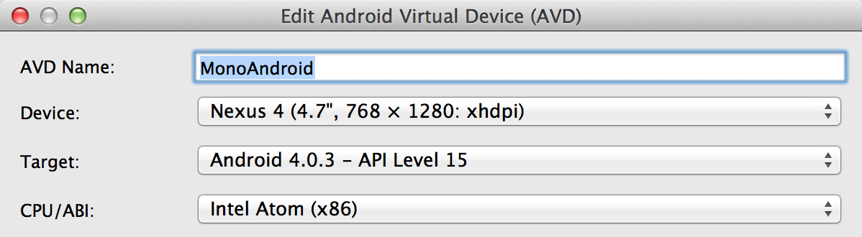

Also, at the bottom of this window, under emulation options select “Use Host GPU.”

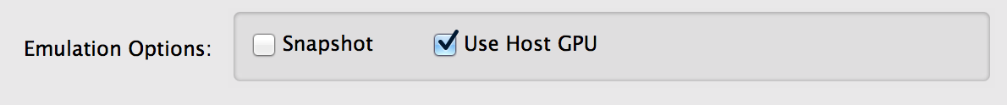

After this, click “OK.” You’ll get a confirmation prompt. Just click “OK” here. This will create the device, and it can now be used. It should show up in the list of Android Virtual Devices now:

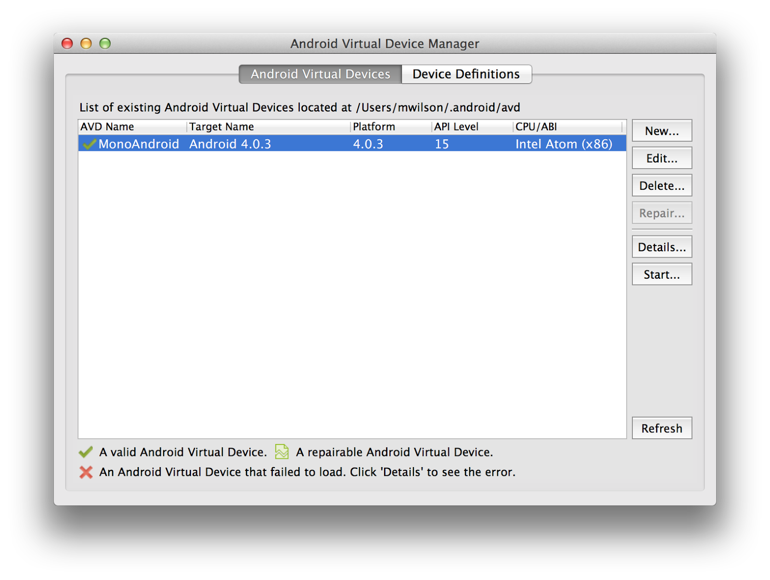

With your new device selected, click “Start…” on the right hand side in order to start the emulator. It will pop up a small dialog full of launch options:

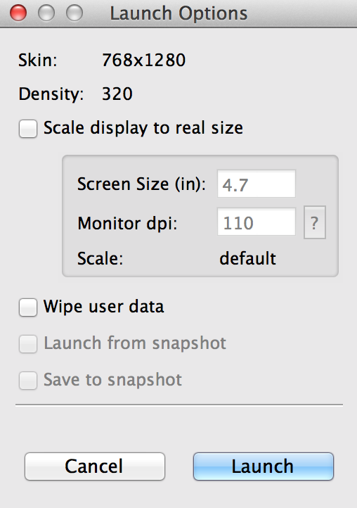

Leave everything the way it is and click “Launch.” An emulator window should pop up:

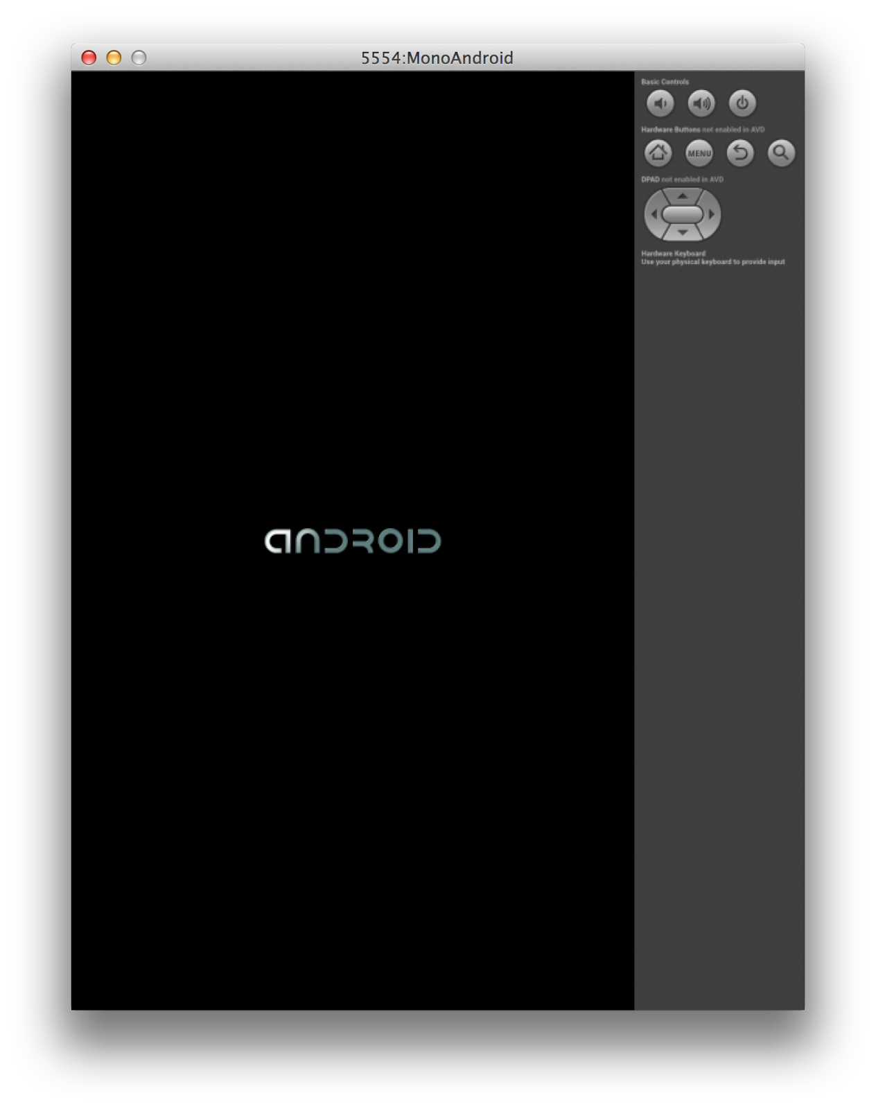

As long as the HAXM module was configured correctly, the Android emulator should start up in a few seconds. Once the “Android” logo disappears, you’ll be presented with a lock screen. You can now interact with the emulator like you would a normal Android phone, and it’s ready to be deployed to for testing out the application.

## Making sure everything works

To ensure that you’ve set everything up correctly, go back to the main IDE. On the top of the IDE window, there will be a “Play” button that you should click:

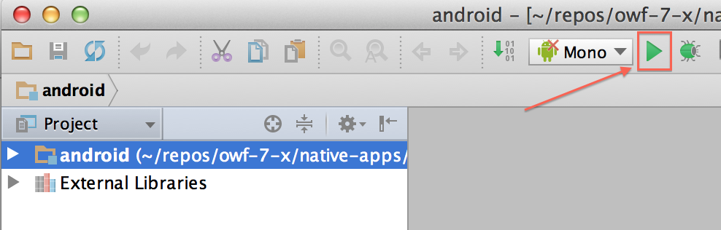

When you click it, you’ll be presented with a list of devices to deploy to. It may take a short while for this window to appear. You should see your new Android device in the list:

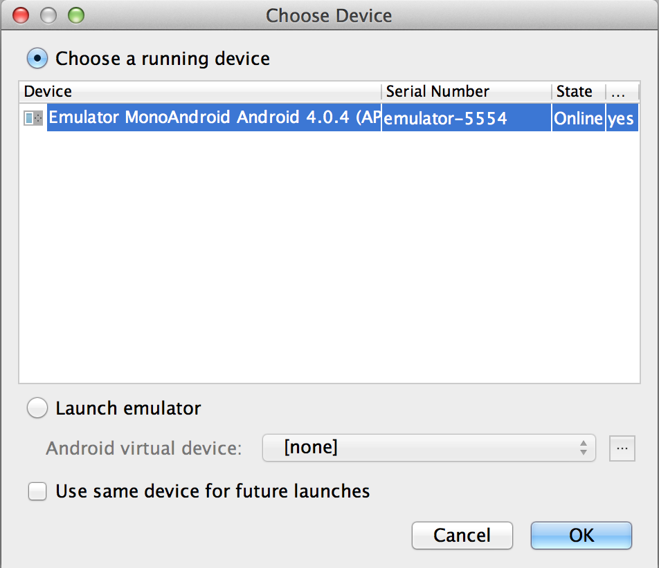

Make sure it’s selected, then press “OK.” The main IDE will open up some logging information at the bottom of the window. This is how you monitor the application. In your code, you can set up custom loggers to aid you in your debugging:

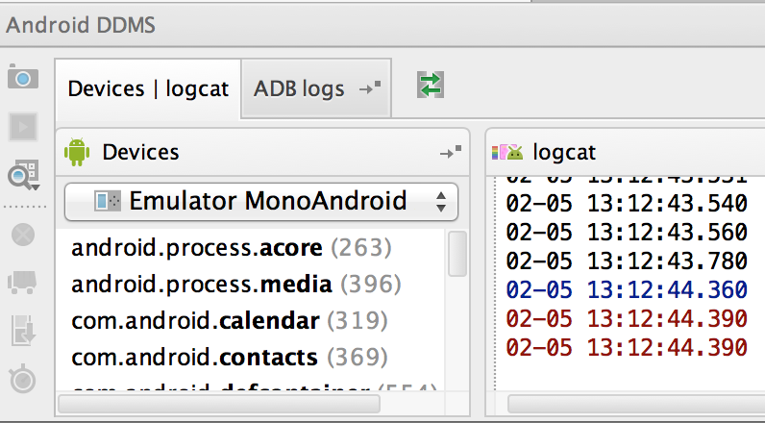

On your running Android emulator, you should see the native app running:

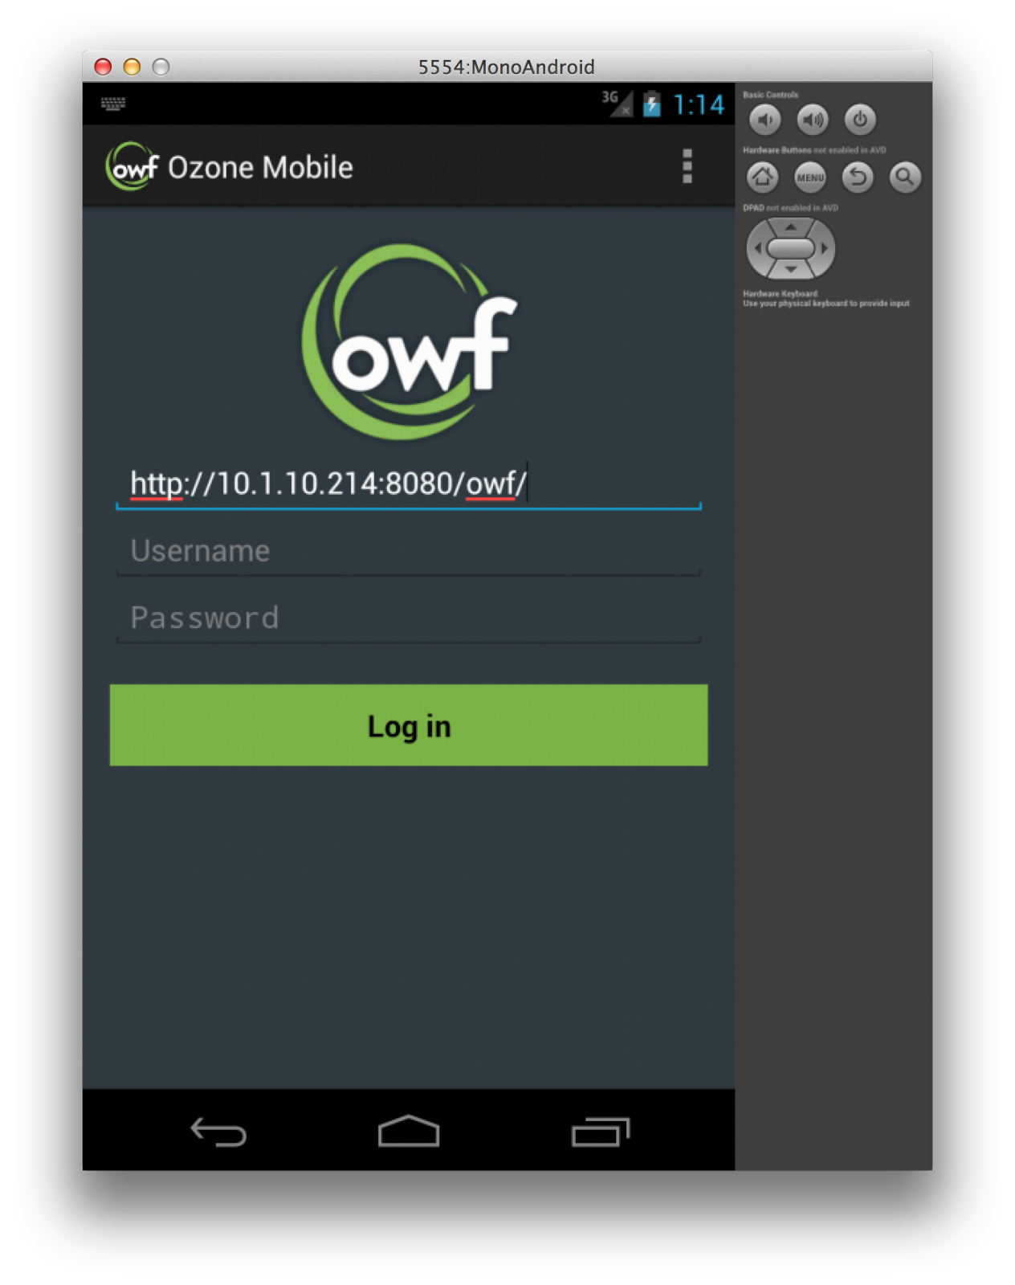

If you see this, you’ve done everything correctly and you should be okay to start coding!

## Deploying onto an Android device

In addition to deploying onto virtual devices, we’re also able to deploy onto hardware devices pretty easily. On a Mac, this is very easy. Linux and Windows require some extra handling. Most of the following material is easily found on <http://developer.android.com/tools/device.html>.

### Enabling USB debugging

This will vary from device to device. At the moment there are two more common possibilities. For each one, you’re looking to enable an option called “USB Debugging,” but it varies in where it’s located on the device:

1. If the device is running Android 3.2 or older, you can find USB Debugging by looking in Settings -> Applications -> Development.
2. On Android 4.0 and newer, you can find USB Debugging in Settings -> Developer options. However, in Android 4.2 and newer, the Developer options are hidden by default. In order to unhide Developer options, go to Settings -> About phone and tap “Build number” seven times. Then you should be able to navigate to Settings -> Developer options.

### Configuring your development system to recognize Android devices

#### Mac OS X

If you’ve got a Mac, you don’t have to do anything. This works out of the box.

#### Windows

If you’ve got Windows, you need to install a USB driver for the Android debugging environment. To do this, go to <http://developer.android.com/tools/extras/oem-usb.html> and locate the manufacturer of the device you’re trying to use and download the appropriate driver. Locate the directions for the version of Windows that you’re running and follow them to install the drivers correctly.

#### Linux

This is a little trickier, as it really depends on which Linux you’re using and what technology it uses. Most Linux installations use udev to manage the various devices that can be connected to a Linux system. The most catch-all way to do this is to make a new udev rule. In Ubuntu, udev rules are located in /etc/udev/rules.d. Make a new file here called “51-android.rules” and copy the following text into it:

SUBSYSTEM==”usb”, ATTR{idVendor}==”0502″, MODE=”0666″, GROUP=”plugdev”

SUBSYSTEM==”usb”, ATTR{idVendor}==”0B05″, MODE=”0666″, GROUP=”plugdev”

SUBSYSTEM==”usb”, ATTR{idVendor}==”413C”, MODE=”0666″, GROUP=”plugdev”

SUBSYSTEM==”usb”, ATTR{idVendor}==”0489″, MODE=”0666″, GROUP=”plugdev”

SUBSYSTEM==”usb”, ATTR{idVendor}==”091E”, MODE=”0666″, GROUP=”plugdev”

SUBSYSTEM==”usb”, ATTR{idVendor}==”18D1″, MODE=”0666″, GROUP=”plugdev”

SUBSYSTEM==”usb”, ATTR{idVendor}==”109B”, MODE=”0666″, GROUP=”plugdev”

SUBSYSTEM==”usb”, ATTR{idVendor}==”0BB4″, MODE=”0666″, GROUP=”plugdev”

SUBSYSTEM==”usb”, ATTR{idVendor}==”12D1″, MODE=”0666″, GROUP=”plugdev”

SUBSYSTEM==”usb”, ATTR{idVendor}==”24E3″, MODE=”0666″, GROUP=”plugdev”

SUBSYSTEM==”usb”, ATTR{idVendor}==”2116″, MODE=”0666″, GROUP=”plugdev”

SUBSYSTEM==”usb”, ATTR{idVendor}==”0482″, MODE=”0666″, GROUP=”plugdev”

SUBSYSTEM==”usb”, ATTR{idVendor}==”17EF”, MODE=”0666″, GROUP=”plugdev”

SUBSYSTEM==”usb”, ATTR{idVendor}==”1004″, MODE=”0666″, GROUP=”plugdev”

SUBSYSTEM==”usb”, ATTR{idVendor}==”22B8″, MODE=”0666″, GROUP=”plugdev”

SUBSYSTEM==”usb”, ATTR{idVendor}==”0409″, MODE=”0666″, GROUP=”plugdev”

SUBSYSTEM==”usb”, ATTR{idVendor}==”2080″, MODE=”0666″, GROUP=”plugdev”

SUBSYSTEM==”usb”, ATTR{idVendor}==”0955″, MODE=”0666″, GROUP=”plugdev”

SUBSYSTEM==”usb”, ATTR{idVendor}==”2257″, MODE=”0666″, GROUP=”plugdev”

SUBSYSTEM==”usb”, ATTR{idVendor}==”10A9″, MODE=”0666″, GROUP=”plugdev”

SUBSYSTEM==”usb”, ATTR{idVendor}==”1D4D”, MODE=”0666″, GROUP=”plugdev”

SUBSYSTEM==”usb”, ATTR{idVendor}==”0471″, MODE=”0666″, GROUP=”plugdev”

SUBSYSTEM==”usb”, ATTR{idVendor}==”04DA”, MODE=”0666″, GROUP=”plugdev”

SUBSYSTEM==”usb”, ATTR{idVendor}==”05C6″, MODE=”0666″, GROUP=”plugdev”

SUBSYSTEM==”usb”, ATTR{idVendor}==”1F53″, MODE=”0666″, GROUP=”plugdev”

SUBSYSTEM==”usb”, ATTR{idVendor}==”04E8″, MODE=”0666″, GROUP=”plugdev”

SUBSYSTEM==”usb”, ATTR{idVendor}==”04DD”, MODE=”0666″, GROUP=”plugdev”

SUBSYSTEM==”usb”, ATTR{idVendor}==”0FCE”, MODE=”0666″, GROUP=”plugdev”

SUBSYSTEM==”usb”, ATTR{idVendor}==”2340″, MODE=”0666″, GROUP=”plugdev”

SUBSYSTEM==”usb”, ATTR{idVendor}==”0930″, MODE=”0666″, GROUP=”plugdev”

SUBSYSTEM==”usb”, ATTR{idVendor}==”19D2″, MODE=”0666″, GROUP=”plugdev”

(Sourced from: <http://codeworkx.de/wordpress/linux-scripts/linux-adb-udev-rules/>)

Afterwards, run:

*chmod 644 /etc/udev/rules.d/51-android.rules*

That should allow you to connect any device you want to your Linux development environment.

### Deploying to the Android device

After connecting the device, powering it on, and correctly configuring your operating system, start up Android Studio. If you’ve configured everything as before, it should start up with our Android project in focus. Here, press the “play” button.

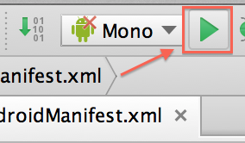

In the list of running devices, you should see your hardware device listed. Select it and click “OK.”

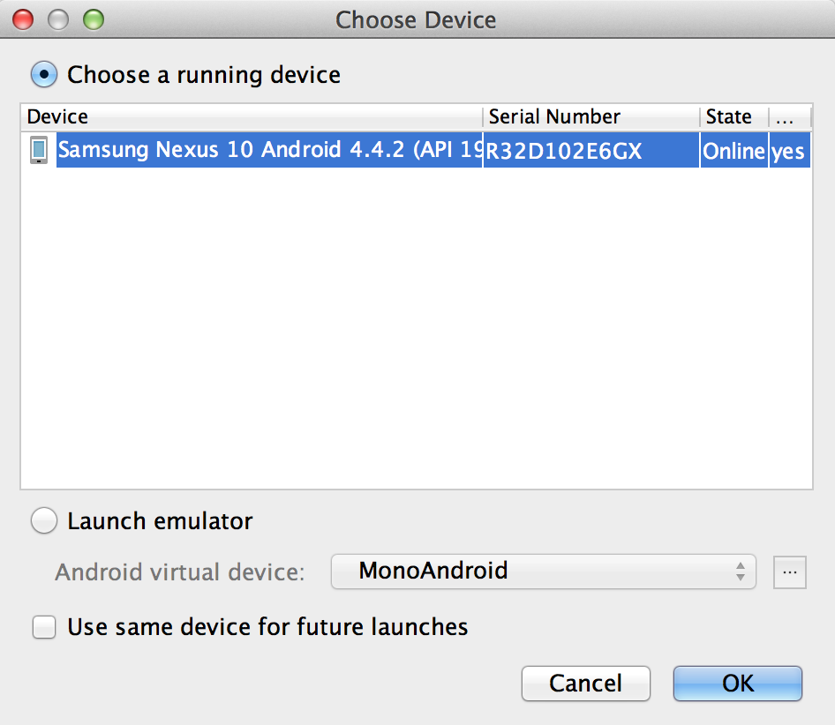

If you’ve already deployed the application onto this device before, you might get a dialog that says the installation of the application has failed due to a package with the same name. The dialog asks if you would like to uninstall the application. Click “OK” to uninstall the old version.

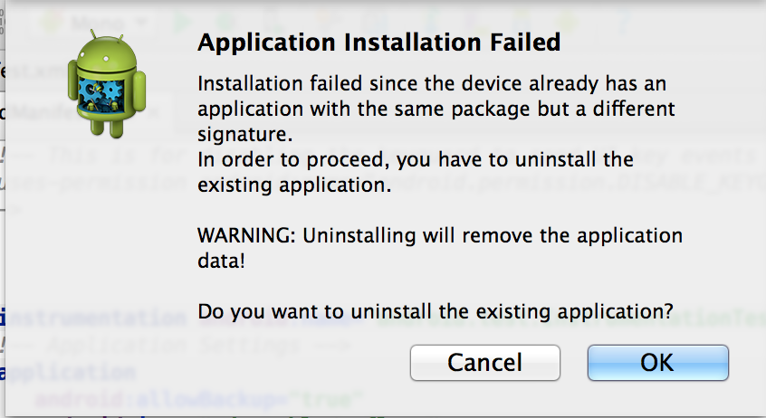

The application will now be deployed and launched onto the device.

# Setting up Xcode

## Signing up for an Apple ID

Before you can install Xcode, you’ll need to set up an Apple ID. Navigate to <https://appleid.apple.com/> and click on “Create an Apple ID.”

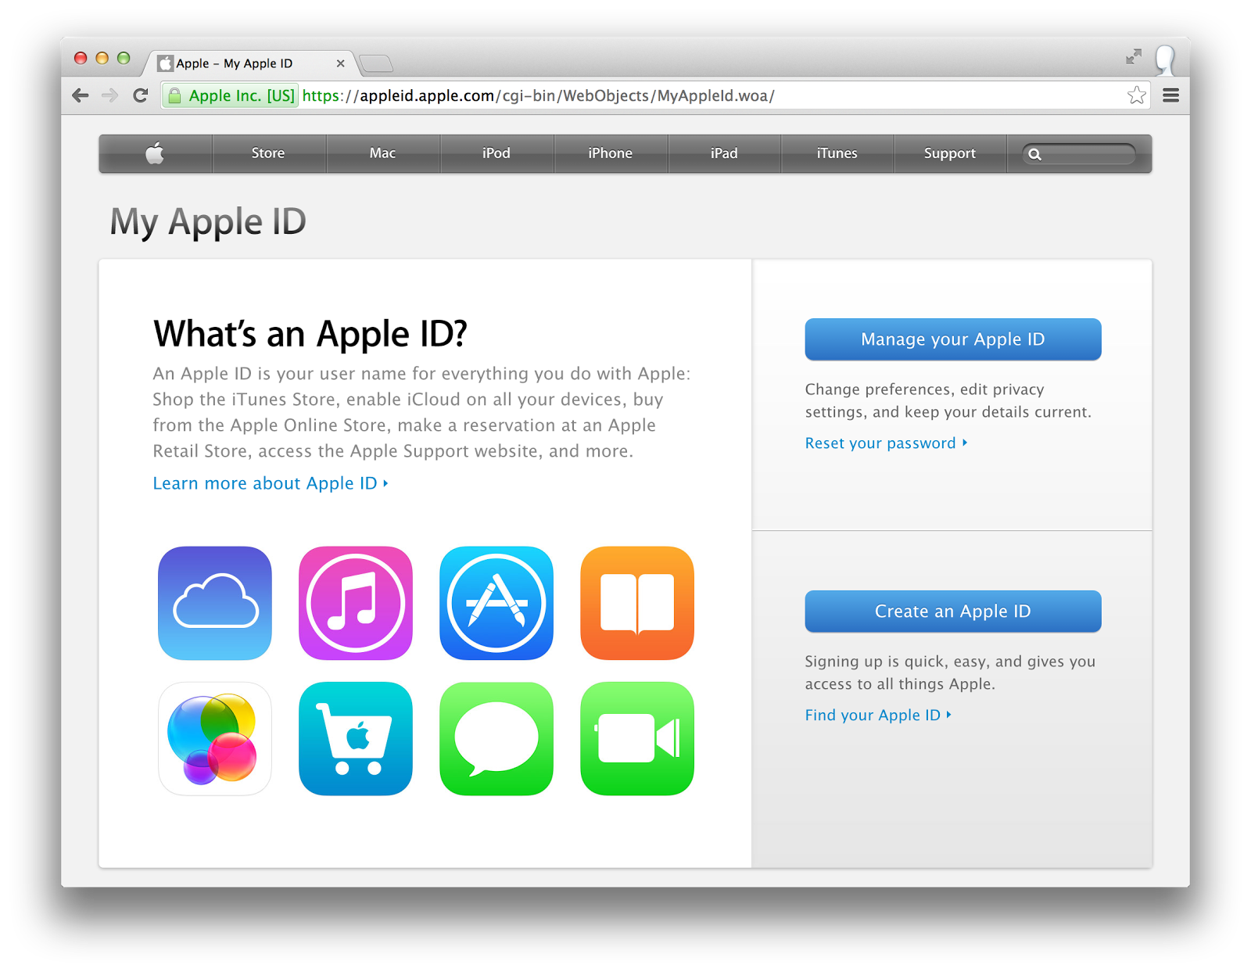

Once you’ve clicked the link, you’ll be taken to a form where you can fill in your account information (name, Apple ID, password, security questions, date of birth, rescue e-mail address, mailing address, newsletter preference). Please fill all this out and click “Create Apple ID” at the bottom.

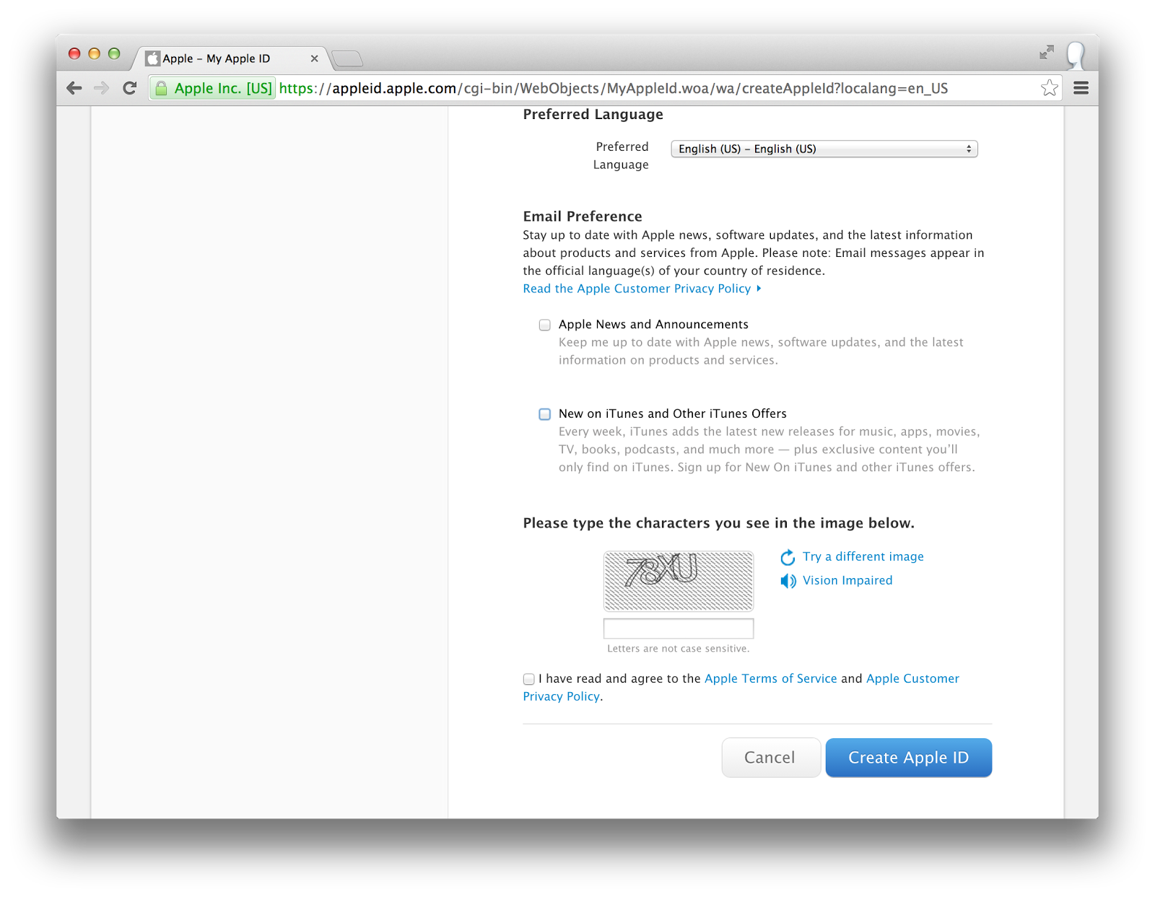

You may be asked to verify your rescue e-mail address, in which case you’ll need to look for the confirmation e-mail in the inbox of the address you used and follow the directions there.

## Installing Xcode

In order to install Xcode, you’ll need to do so from the App Store. By default, this will be on your dock on the bottom of the screen. You can click the icon here to launch it.



If it’s not located there, you should be able to find it in your applications folder. Click on Finder (the leftmost icon in the dock), Applications, and then on the App Store.

After the App Store is running, search for “Xcode” in the search box in the top right corner and press enter.

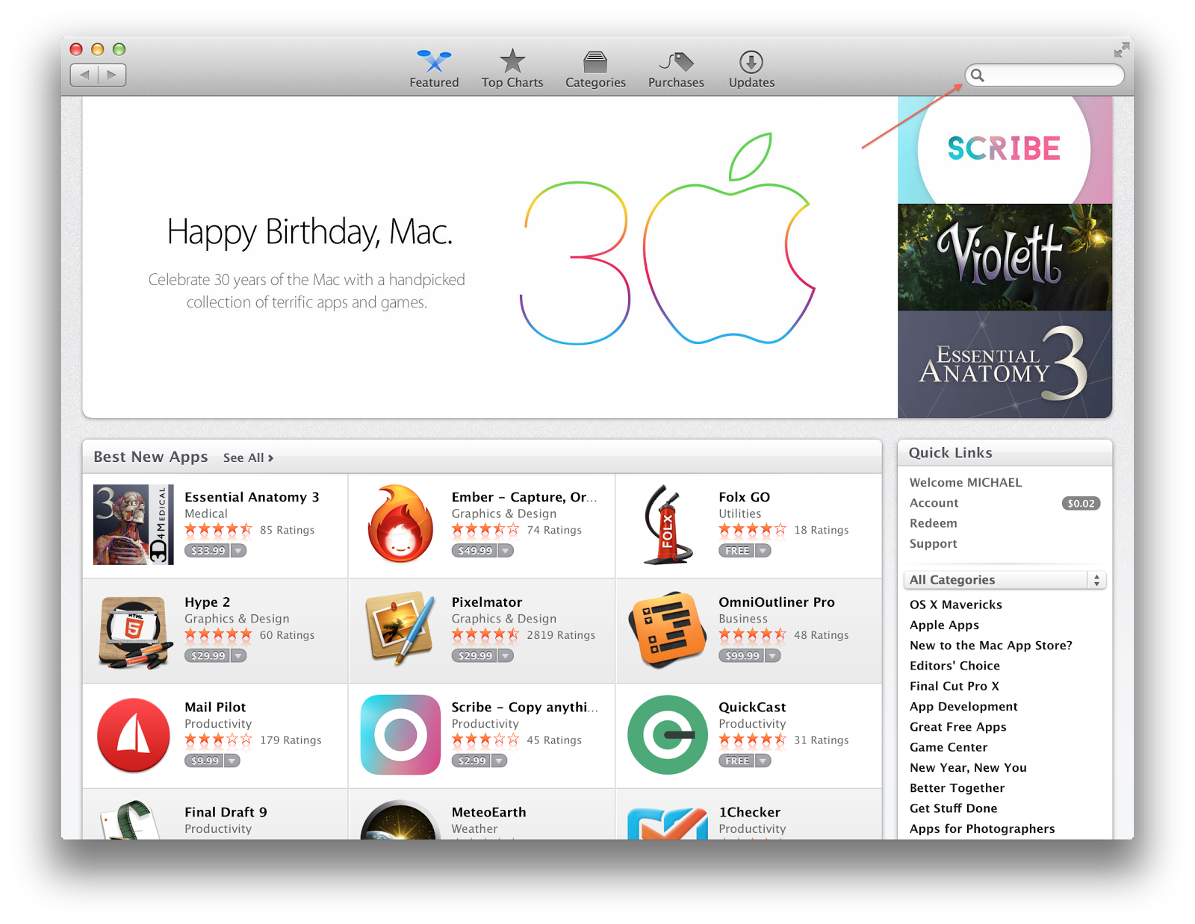

It will show a list of search results, and Xcode will most likely be at the top left spot. Click the result.

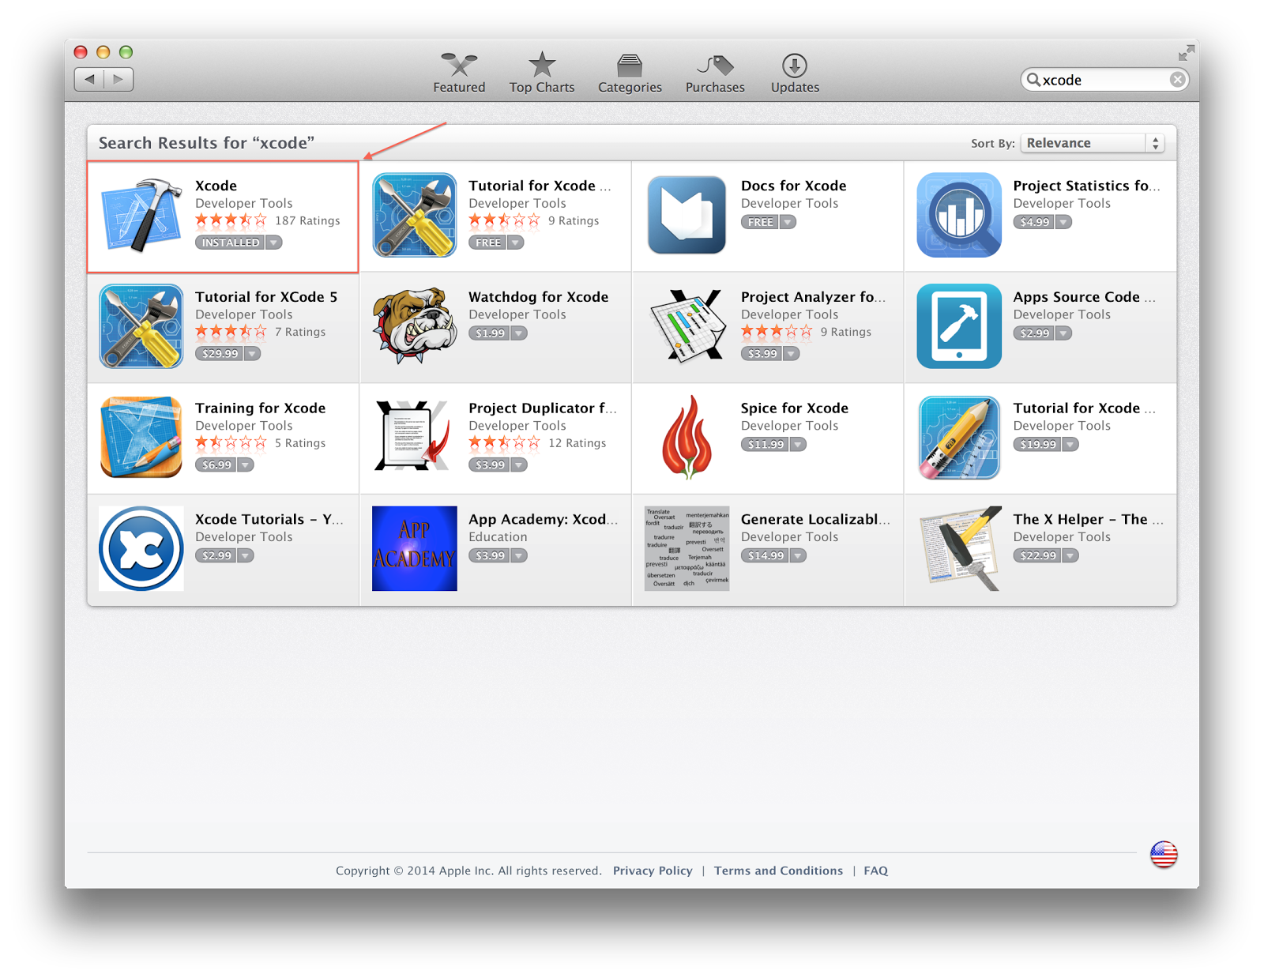

This will bring you to the Xcode page. It should look something like this:

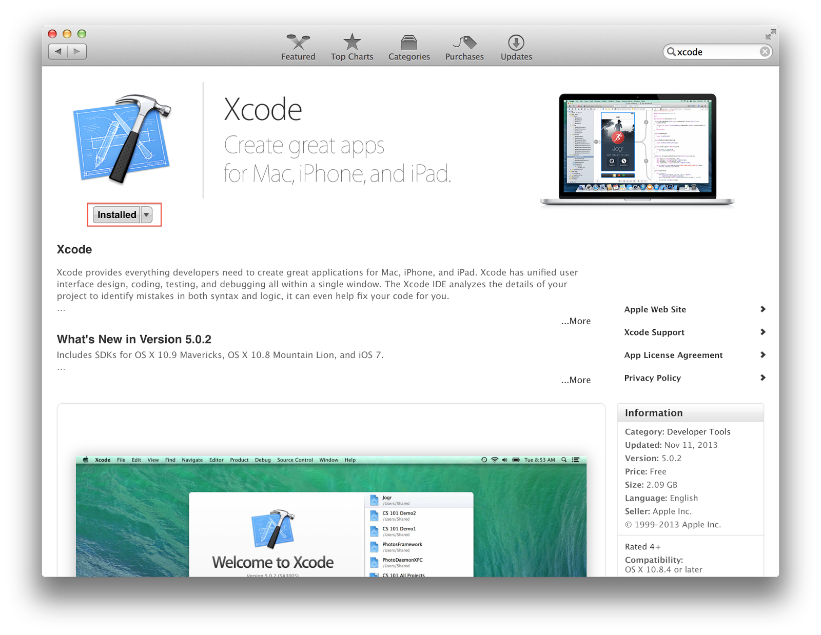

Yours will look a little different. The highlighted button will be marked “Free” instead of “Installed.” Click on this to start the installation. You will most likely be prompted for your Apple ID credentials. Enter them here, and wait for Xcode to finish installing. You’ll know installation was successful once the “Free” button changes to “Installed” like above.

## Running Xcode for the first time

When you first run Xcode, you’ll be prompted with a license agreement. Click “Accept.”

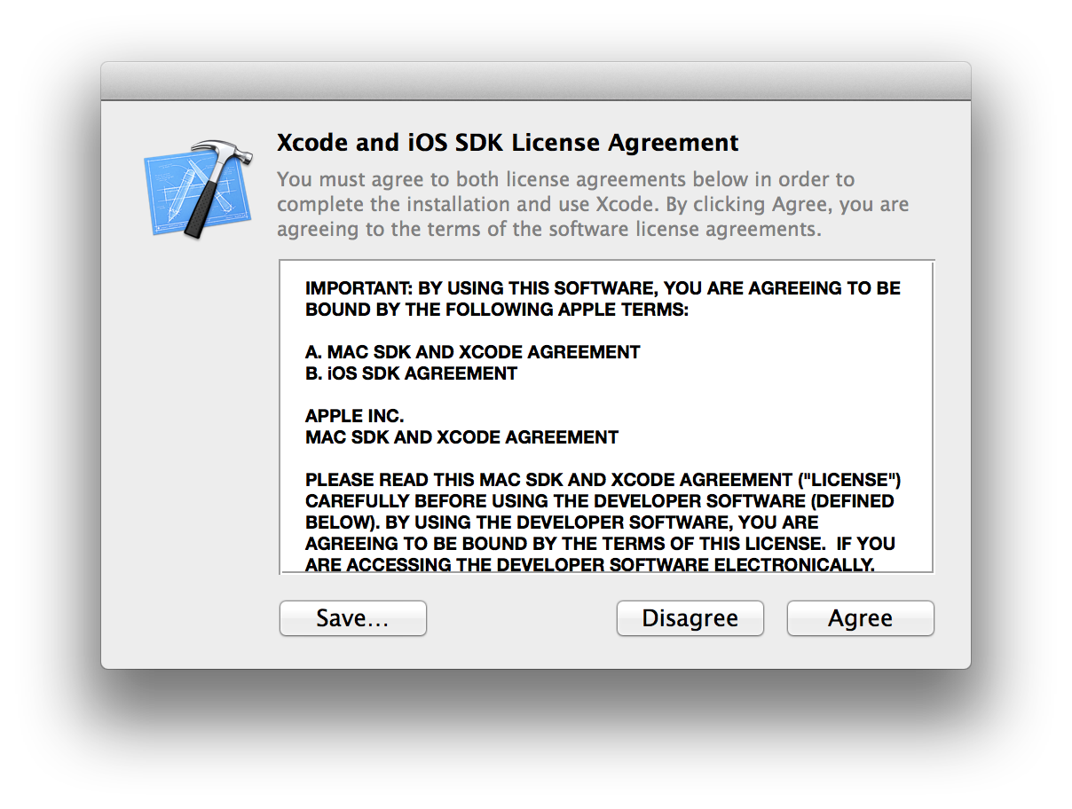

This will prompt you for administrative access. Fill out your username and password on your local machine and click “OK.”

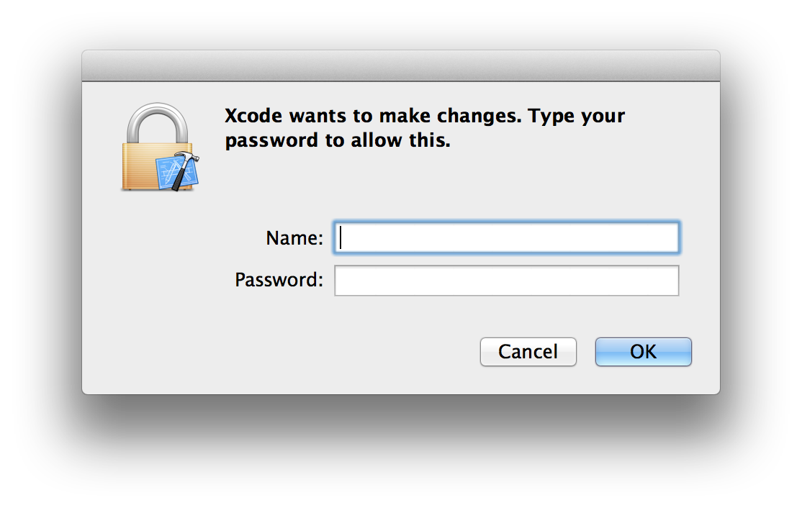

After a brief wait, you’ll be presented with the following splash screen:

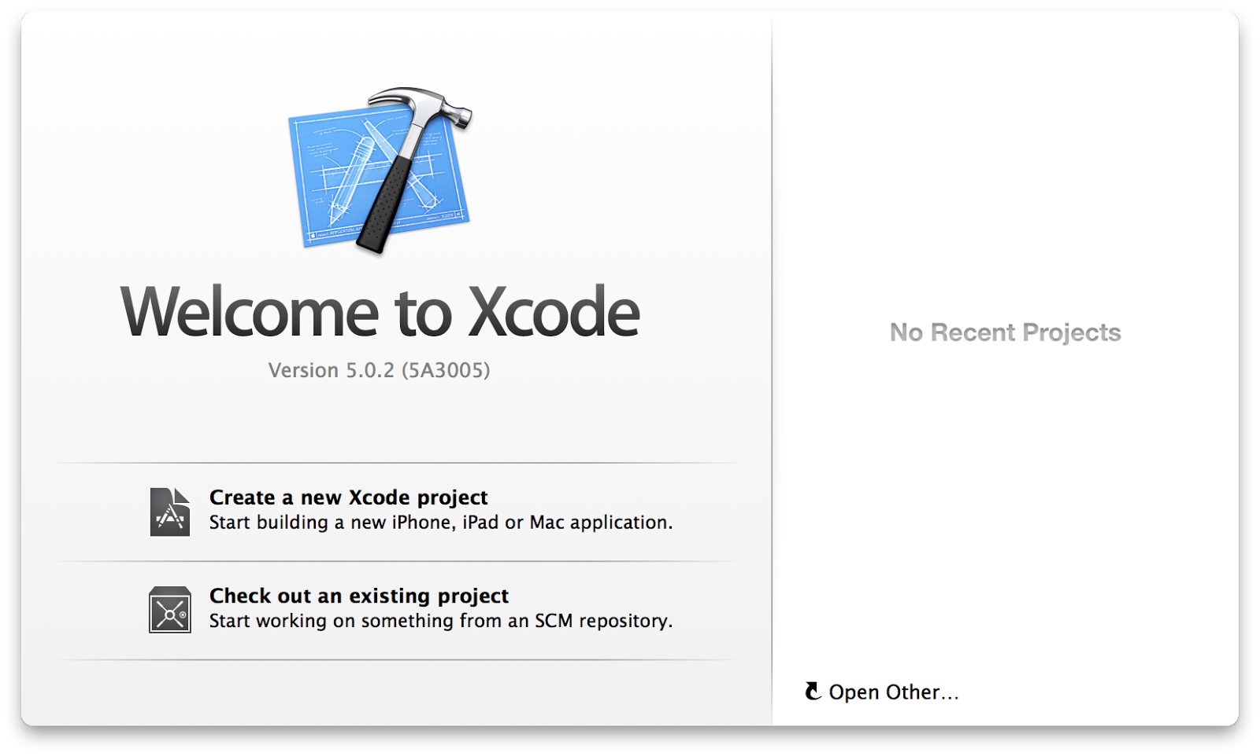

Click on “Open Other…” on the right side of the splash screen at the bottom. This will open a file open dialog. You’ll want to navigate to the repository directory you’ve created, and move to owf-7-x -> native-apps -> ios -> Mono. Here, click on “Mono.xcodeproj” and click “Open.”

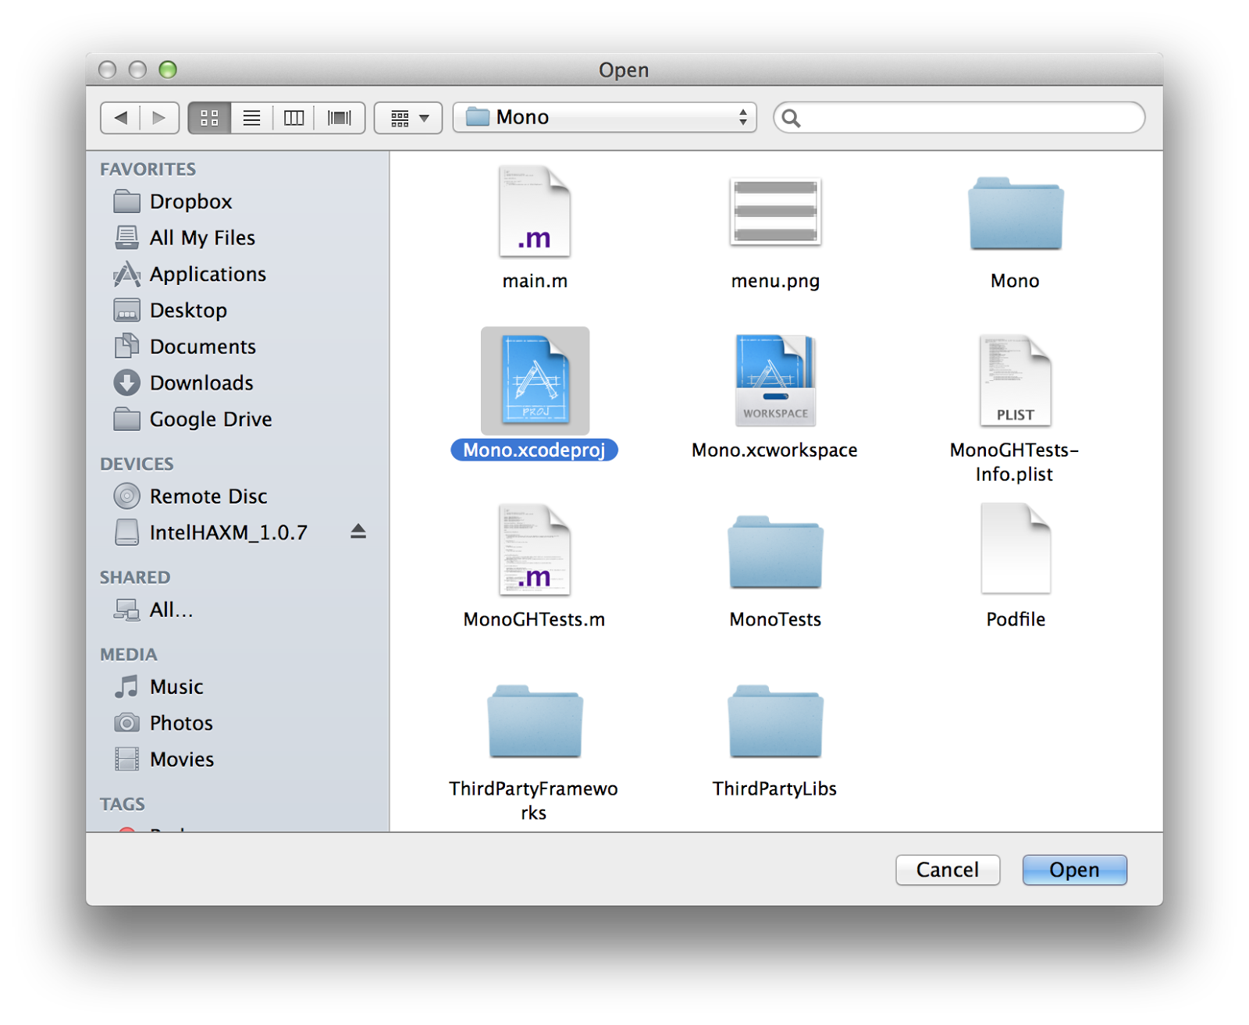

This should drop you into the main Xcode IDE, and you should be ready to code.

## Testing everything out

You should make sure you’re able to run the application on a virtual iOS device. Fortunately, unlike the Android Studio set up, we don’t have to manually set up the iOS devices. These are bundled into Xcode for us. All you should have to do is select a device and press the “play” button on the top part of the IDE window.

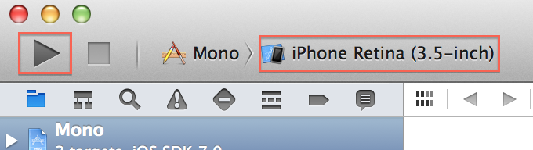

By default, iPhone Retina (3.5-inch) should be selected. Leave this for now and press the play button. You should get a big iPhone on your screen with the native app running in it.

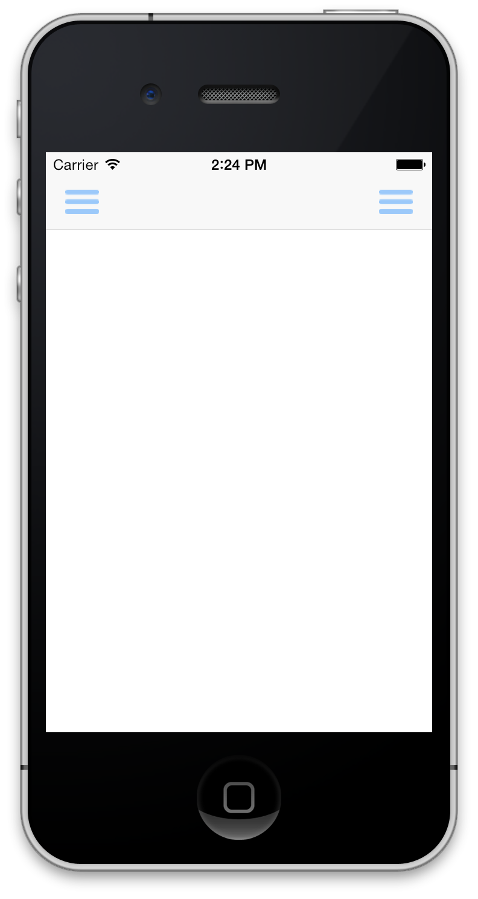

If you see this, you should be good to go!

## Deploying onto an iOS device

TODO: Write this section after we get an iOS Developer account.